Sector Operational Programme for Transport

2014-2020

Republic of Macedonia

4 November 2014

1. SECTOR ANALYSIS 4
1.1 Sector general overview 4
1.1.1 National sector policy and socio-economic context 4
1.1.2 Description of the Transport Sector 4
1.1.3 National Transport Priorities 6
1.1.4 Institutional Arrangements 7
1.1.5 Sustainability and maintenance 10
1.1.6 Legal Framework 11
1.2 Railway Transportation 12
1.2.1 Railway Infrastructure 12
1.2.2 Condition of the Rail Infrastructure along the Corridors VIII and X 13
1.2.3 Border crossings 15
1.2.4 Traction and Rolling stocks 15
1.2.5 Rail safety 15
1.2.6 Investment in the rail sector 16
1.3 Road Transport 17
1.3.1 The Road Network 17
1.3.2 Condition of the Road Infrastructure along the Corridors VIII and X 19
1.3.3 Border crossings 19
1.3.4 Road safety 20
1.4 Air transport 21
1.5 Inland waterways 23
1.6 Urban and green transport 24
2. Socio-economic analysis (including SWOT analysis) 25
2.1 Continuation of the national investment policy and IPA I assistance under Operational Program for Regional Development 2007 – 2013 25
2.2 SWOT Analysis 27
3. Scope for a sector approach 30
3.1 National sector policies and strategies 30
3.2 Institutional settings, Leadership and Capacity 31
3.3 Sector and Donor Coordination 31
3.4 Mid-term budgetary perspectives 32
3.4.1 Performance assessment framework 32
3.5 Public Finance management 33
3.6 Macro-economic framework. 33
3.7 Overall assessment 34
4. Objectives of the IPA II sector approach 36
5. Operational features of the programme 38
5.1 Geographic and thematic concentration 38
5.2 Interaction of the programme with IPA II programmes in other sectors 38
5.3 Complementarity of IPA II assistance in the sector with other donors 38
5.4 Equal opportunities and gender mainstreaming 39
5.5 Climate action and sustainable development 39
5.6 Programme strategy – Actions and activities 40
5.6.1 Priority action 1 – Rail transport infrastructure 40
5.6.1.1 Upgrading and modernization of the Rail Transport Infrastructure along the SEETO comprehensive network (Corridors VIII, X and Branch X d) 41
5.6.1.2 Eligible Interventions under IPA II 45
5.6.2 Priority action 2 – Road transport infrastructure 46
5.6.2.1 Upgrading and modernization of the Road Infrastructure along the SEETO comprehensive network (Corridors VIII, X and Branch X d) 48
5.6.2.2 Eligible Interventions under IPA II 51
5.6.3 Priority action 3 – Horizontal sector assistance 52
5.7 Methodology for selection of projects 55
6. Indicative List of major projects 57
7. IPA II Financial allocations per year 57
8. Overview of the consultation process 62
9. Implementation, monitoring and evaluation arrangements 63
9.1 Description of relevant structures and authorities for the management and control of the programme 63
9.2 Monitoring arrangements 66
9.3 Evaluation arrangements 67

SECTOR ANALYSIS

Sector general overview

National sector policy and socio-economic context

Republic of Macedonia is a country of 25.713 sq. km and population of about 2 million. It is a landlocked country, located in the midst of the Balkan Peninsula and bordering:
- In the South, an EU member state, with a border of 246 km long,
- In the East, an EU member state, with a border of 148 km long,
- In the North, with a border of 221km long,
- In the West with a border of 151 km long.

According to the NUTS classification there are eight NUTS III regions and 84 municipalities. The main cities and towns are widely distributed, with Skopje the national capital city, being located in the north east of the country. As a result, the country has a monocentric regional structure based on the dominance of the capital city Skopje that attracts about 40 % of the urban population.

The Skopje region dominates with approximately with 29% of the national population. There are only 13 towns and cities with a population above 50,000, of which 4 are in the Skopje region and no such large towns or cities in the Eastern region. The annual growth rate of 2.0% is typical in the recent years.

In 2002 the country had a population of 2.022 million and by 2012 it had increased to 2.061 million. The 2002 census showed that majority community constitutes 64% of the population and non-majority community constitutes 35%, out of which Turks, Roma and 3 other sub-groups constitute 10% of the population.

The efforts of the governmental policy are focused on the provision of: increased economic growth and employment, as a precondition for increased standard of living and improved quality of life, integration of the Republic of Macedonia into EU and NATO, uncompromising fight against corruption and crime and efficient law implementation by undertaking deep reforms in the judiciary and public administration, maintenance of good inter–ethnic relations based on the principles of mutual tolerance and respect and investment in education, science and information technology as elements of a knowledge–based society.

The candidate country status for accession in the European Union and its membership in the World Trade Organization have created conditions for greater opening of national economy towards international global market, fostering of investments, strengthening of GDP and by all these – prosperity of the national economy.

Key objectives to be achieved with the realization of the economic program of the Government of the Republic of Macedonia are: increased production, exports and investments; unemployment reduction and improvement of the citizens’ standard of living, development of agriculture and improved farmers’ standard, protection of the standard of living of the vulnerable categories of citizens and economic infrastructure development.

Description of the Transport Sector

The geographic location of the country is at the crossroad of South-Eastern Europe, making it an important transit route for land traffic between Central Europe, the Aegean Sea, the Black Sea and the Adriatic Sea. The favourable landlocked geographical location of the country has contributed to the development of international traffic on two Trans National Axes: North-South (Corridor X) and East-West (Corridor VIII) linked to the Trans European Transport Networks.
The basic infrastructure of the country is relatively well established and it can be considered as a good basis for further modernization. Several significant transport routes connect the country with the Central and Eastern Europe, with South and South-East Europe and beyond. Further development of the transport sector will contribute towards competitiveness of the national economy and balanced regional development.

The transport of passengers and goods in the Republic of Macedonia is utilizing the following modes of transport:
- Road transport
- Railway transport
- Air transport
- Inland waterway transport
- Urban transport

In general terms the physical infrastructure consists of about:
1. 14.159 km. public roads, of which 236, 5 km are motorways, 911 km are national roads, 3771, 5 km are regional, and 9240 km are local roads
2. 925 km railways, and
3. two (2) international airports.

The two Trans National Axes (Corridors VIII and X) that cross the country are important because they support the easy movement of people and goods within the country and also provide connections to regional neighbours and further to other European Countries.
Illustration 1: Transport Corridors in SEE Europe, with focus on the ones crossing Republic of Macedonia

The EU policy regarding the extension of the major Trans-European Transport Axes to the EU neighbouring countries is confirmed and the orientation is already given in the Memorandum of Understanding (MoU) on the Development of the South East Europe Core Regional Transport Network. The SEETO Comprehensive network is established by the technical secretariat of the South East Europe Transport Observatory (SEETO).

The development of the transport infrastructure has achieved good results in the recent period. However, it does not have all the features and characteristics of a fully functional, well-developed and modern transport infrastructure system.

Main challenges remain the financing of transport infrastructure development and relatively slow uptake of innovative ideas and technology, which lead to reduced opportunities for taking advantage of alternative sources of funding including Public- private partnership (PPP), road tolling and new modes of transport such as multi-modal and combined transport.

National Transport Priorities

The national priorities for the development of the transport sector are defined in the following national and regional strategic documents:

- National Transport Strategy 2007-2017
- Public Investment Programme 2011-2013
- Five year programme of the Public Enterprise for State Roads 2013-2017
- Multi-annual Plan of South East Europe Transport Observatory (SEETO)
- Programme of the Government 2014-2018
- Pre - accession Economic Programme 2014-2016 (PEP 2014-2016)

The Government recognises the importance of transport in the current phase of national development. The National Transport Strategy (NTS) was adopted by the Government in July 2007 determining the national transport development priorities for the period 2007-2017 and is updated every two years. The focus of the National Transport Strategy is on the following objectives:

- Promotion of the economic growth by building, enhancing, managing and maintaining transport services, infrastructure and networks to maximize their efficiency
- Improvement of the safety of journeys by reducing accidents and enhancing the safety of pedestrians, cyclists, drivers
- Improvement of integration by making journey planning and ticketing easier and working to insure smooth connection between different modes of transport
- Protection of the environment and improved health by building and investing in public transport and other types of efficient and sustainable transport which minimize emissions and consumption of resources and energy
- Promotion of the social inclusion by connecting distant and disadvantaged communities and increasing the transport network accessibility

These objectives shall be achieved by:
- Modernisation and extension of the infrastructures on Corridors X and VIII to enable transport service delivery to be improved both in qualitative and quantitative terms
- Building modern transport infrastructure and facilities with enhanced safety features that, together with modern targeted safety awareness campaigns, contribute to safer and more secure transport
- Initiation of a public transport operators’ forum to address ways to promote better integration between modes and thereby increase public transport patronage by providing easy and convenient ways to use the various modes
- More and better opportunities through improving the transport networks, to provide improved mobility for all and provide better access to goods and services, particularly for those in the rural areas leading to improved social cohesion
- Better quality and more transport links that will enable improved access to health centres and facilities

Regarding the environmental aspects of the transport system, the following TSOPics related to the environmental sustainability are to be the outstanding areas where the national transport policy will focus its consideration:

1. Protection of water resources-The main objective is to reduce the transportation impact on the quantity and quality of the water environment. The considerations are also applied on the physical aspect of water bodies, including for example potential morphological alterations arising from disturbances to existing hydrological patterns by engineering works, dredging etc;

2. Protection of biodiversity- The main objective will be to preserve biodiversity at all levels and according to the protection of national environmental programs and strategies;

3. Improving the air quality- Transport is the major contributor to local air pollution, especially in terms of nitrogen dioxide (NO₂) and particles. This includes effects on local air quality in terms of human health and biodiversity. The National Transport Strategy will be focused on improving the air quality through reducing emissions and pollution from the transport system. The Strategy promotes reduction of the overall traffic volumes which will positively assist in reducing the air pollution. In addition, measures are promoted for reducing the negative impact from the human activities associated with the construction of new transport infrastructure, including extraction of materials and energy use, which will be fully assessed at the design stage. The Strategy also encourages the introduction of demand management measures to reduce traffic flows, to prevent induced traffic from taking up the public transport road space, to promote use of alternatively fuelled vehicles and to include public transportation;

4. Improving the use of land- The Strategy promotes measures for reducing the negative impact from the human activities, especially the use of arable and agrarian land for the purpose of transport infrastructure. The measures will be in line with the particular institutional policy and the National Spatial Plan.

5. Reducing the negative climate impact-Reducing the energy consumption and CO₂ emissions and the associated impacts of climate change will be an important issue of the future sector development. The Strategy will support measures for reducing climate change effects through the inclusion of policies as to reduce the need for travelling and to promote sustainable travelling as well as measures on promoting use of alternatively fuelled vehicles.

6. Protecting the existing material assets- New developments in infrastructure require new resources and waste generation.. The use of material assets will be an integral part of environmental appraisal at the national and/or local level. Use of recycled or secondary made aggregates should be encouraged where possible.

7. Protecting the landscape-Both the physical and visual appearance of transport infrastructure can pose a major impact on the existing landscape. Transportation activities could have impact on the character and integrity of the landscape, in particular on areas designated at the national or local level on the grounds of their natural beauty. New infrastructure projects can have a significant impact on the quality of panoramas, specific views and the visual environment of sensitive areas. The strategy will promote protection on the character, diversity and unique qualities of the landscape. Environmental appraisal at the national and local level will determine how the infrastructure will fit with the landscape and will propose measures that will retain, improve and protect characteristic features and landscape patterns.

Institutional Arrangements

The Ministry of Transport and Communications (MTC) is in charge of creating and implementing transport policy including national strategies and action plans, inspection and enforcement. The State Transport Inspectorate, the Railway Safety Directorate and the Captaincy-Ohrid, within the Ministry, are responsible for supervising the implementation of relevant laws and rules.

Road administration and restructuring activities

The national road network is managed by the Public enterprise for State Roads (PESR). Public enterprise for State Roads is responsible for designing and implementing the Annual Programme for planning, funding, construction, reconstruction, maintenance, and protection of the national and regional road network. In 1996 the Law on Public Roads was adopted, according to which the Fund for National and Regional Roads of Republic of Macedonia was functioning from 1996 to 2008. With the amendments of the Law on Public Roads as of 11th July 2008, the Agency for Public Roads was established as the legal successor of the Fund for National and Regional Roads of Republic of Macedonia. With the Law Amending the Law on Public Roads as of 27th December 2012, the Public Enterprise for State Roads was established and took over the rights, responsibilities, employees, property, assets and archives of the Agency for State Roads.

Maintenance of the national road network is under auspices of the "Public Enterprise Makedonija pat" which, in accordance with the Law on Public Roads, is competent and responsible for the protection and maintenance of the national and regional road network in the country including: designing smaller road facilities, paving smaller sections and patching holes, design, fabrication and installation of vertical and horizontal signalization, road protection, automatic and manual traffic counting, cadastre of roads and bridges, information service for the state of the roads, and more.

Rail administration and restructuring activities

Railway infrastructure and transportation are managed by two state-owned public enterprises, Public enterprise for railway infrastructure "Macedonian Railways" Skopje and Joint Stock Company for Transport "Macedonian Railways Transport" JSC Skopje, as a result of separation into two new entities of the "Public Enterprise Macedonian Railways" in 2006.

Public enterprise for railway infrastructure "Macedonian Railways" Skopje as priority activity has service related to land transportation, namely organization and regulation of railway service, managing with systems for regulation and safety, management of railway infrastructure, construction of railway infrastructure, reconstruction of railway infrastructure, repair of railway infrastructure, maintenance of railway infrastructure, protection of railway infrastructure

Joint Stock Company for Transport "Macedonian Railways Transport" Skopje is in charge of transportation of passengers and goods for public or personal needs in domestic and international traffic.

Other bodies of importance for rail sector:
Agency for regulation of the rail sector - (regulatory body) provides a transparent and non-discriminatory operation of the infrastructure and rail carrier. Agency actively controls the quality of service provided by all market participants as rail services.

Administration for safety in railroad system - (safety authority) issues certificates and authorisations for all the rail stakeholders, proposes new legislation regarding the safety of the railway system and enable transparent access to primary and secondary legislation of all participants in the sector.

Committee for investigations of serious accidents as part of the General Secretariat of the Government is responsible for investigation of incidents and accidents in the rail sector.

Aviation administration and restructuring activities

Ministry of Transport and Communications through the Aviation Department has the following responsibilities in the field of aviation:
- Drafting the national strategy for developing aviation;
- Implements the policy of the Government in the field of aviation;
- Implements the policies of the Government in the provision of concessions in the field of aviation;
- Proposes laws in the field of aviation and prepares and adopts the bylaws;
-Supervises the work of CAA (Civil Aviation Agency);
- Implements a procedure for temporarily concession under forced administration;
- Appoints an independent slot coordinator for the allocation of slots for take-off and landing, and
- Establish a commission to investigate accidents and serious incidents.

Transformation of the Civil Aviation Agency
Pursuant to Article 7, paragraph 2 of the Aviation Act, the Civil Aviation Agency is an independent state body that functions as a legal entity. The transformation of the Civil Aviation Agency is an obligation arising from Article 193 of the Law on Aviation. As a result, the sector in the civil aviation agency responsible for air traffic control has become a separate joint stock company in state ownership, with activity "provision of air navigation services”. The Agency for Civil Aviation will retain regulatory functions of air regulation in aviation. The new joint stock company in state ownership as service provider of air navigation M-NAV AD Skopje is registered in the Central Register on 04.06.2009.

Air Navigation Service Provider (ANSP)
The establishment of joint stock company in state ownership functioning as air navigation service provider M-NAV AD Skopje should enhance the efficiency and lead to improvements not only integrated in the organizational structure and technology of work, but also in terms of increasing traffic safety as the highest priority on raising the quality of ANS services and availability for end users. The new joint stock company shall be designated provider of air navigation services in the air space of the country, if it has a certificate under the Law on Aviation, and this is maintained as a permanent validity.

Joint Stock Company for Airport Services “Airports of Macedonia "- Skopje
The new joint stock company for airport services "Airports of Macedonia" - in state ownership is registered in the Central Register on 22.08. 2008. In accordance with ICAO standards and regulations of the EU, the following commissions and committees exist:
- Commission to investigate serious accidents and incidents in aviation
This committee investigates accidents and serious incidents in aircraft or parachutes the airspace of the Republic of Macedonia and is independent in its work. There is a permanent member appointed by the Government and temporary members that in case of accident or incident of serious aircraft or parachute are appointed by the Minister of Transport and Communications from the list of aviation specialists, depending on the type of aircraft in question
- National Committee for Aviation Safety
The work of the committee including representatives from the Ministry of Transport and Communications, Ministry of Defense, Ministry of Interior, Ministry of Finance (Customs), airport operators, airlines and air navigation service providers. The committee works as a permanent committee for coordination of all activities to ensure all actions for unlawful conduct in the aviation. The Committee is responsible for taking preventive measures, organized action and removal of consequences of actions directed against the security of civilian air traffic.
- National Committee to facilitate transport in air traffic
The committee consists of representatives from the Ministry of Transport and Communications, Ministry of Defense, Ministry of Interior, Civil Aviation Agency, air navigation service provider, Customs, Air ports operators, providers of airport services and airlines. The Committee is responsible for taking measures to facilitate the acceptance, accommodation and sending aircraft, passengers, baggage, cargo, mail and more.
- National Slot Coordinator (NSC)
Currently, each airport in Republic of Macedonia performs allocation of slots and thus has a direct impact on airlines and flight schedules. The Law on Aviation provides appointment of independent national coordinator to RM to allocate slots for takeoff and landing.
Independent national coordinator for the allocation of slots is appointed only if the flow of passengers at the airport, exceed one million per year and if there is continuous lack of facilities handling. In this case, the further allocation of slots is important at least half of all new or returned slots to allocate to new interested carriers, so as to stimulate competition.

Inland waterway administration

The Captains Port office in Ohrid scope of work is the regulating relations between participants in the internal (lake and river) sailing. In Captains Port office in Ohrid, the Department of Inland Waterways performs technical and professional duties in the field of safety of inland navigation; issuing licenses for the use of waterways, ports, port places, berths and bathing areas; performs registration and deletion of vessels in the register; keep a register of ships and boats , runs the registry and issue ships logs, boarding permits , authorizations for carrying out appropriate title for the boat and certificates of competence to drive a boat, authorizing the arrival of foreign yachts and boats , organized rescue human lives and property in inland waters ; authorises the removal of sunken vessels ; inspect the work and activities of the participants in inland navigation(lakes); performing inspection supervision in inland navigation transport ; taking administrative and other measures relating to the actions of participants in inland navigation.

Sustainability and maintenance

Works related to sustainability and maintenance of the public roads is under auspices of the "Public Enterprise Makedonija pat" (national and regional road network), the City of Skopje and the municipalities in the Republic of Macedonia (local road network).

Each year the legal entities in charge, draft year programs aligned with budgetary allocations for protection and maintenance of road network, including designing smaller road facilities, paving smaller sections and patching holes, design, fabrication and installation of vertical and horizontal signalization. The year programs are in line with the five year program for development and maintenance of the public roads adopted by the Government of the Republic of Macedonia upon proposal by the Public Enterprise for State Roads and include detail description of the actions to be undertaken, locations, scope of works, budgetary allocations and time frames for execution.

The management of the construction, reconstruction, overhaul, maintenance, protection of the railway infrastructure, organization and regulation of the railway traffic, management of the regulation and safety systems and assigning of the infrastructure capacities as activities of public interest are performed by the "Public Enterprise Macedonian Railway Infrastructure-Skopje" (PE MRI).

PE MRI, according to the three year National Program for Railway Infrastructure (adopted by the Parliament of Republic of Macedonia), is obligated to issue a annual business plan which include the investment and financial programs. The business plan is prepared in order to achieve optimal and efficient utilization and development of the railway infrastructure which will provide financial balance of the infrastructure manager as well as realize other technical, financial and service goals. PE MRI, in its business plan, is obligated to determine the methods for realization of the investment and financial programs.

Based on the three year National program, PEMRI prepare an Annual Program for Financing of the Railway Infrastructure where the funds are secured through the Ministry of Transport and Communications. For the realization of the Annual Program PE MRI, through the Ministry of Transport and Communications submit a report to the Government of the Republic of Macedonia during the first quarter of the following year.

The airports are under concession for 20 years and the Concessionary is in charge for the operation, development and maintenance of the two national airports.

Legal Framework

Since 2002, the country commenced the process of harmonization of its national transport legislation with the EU acquis. The approximation of the transport legislation is an important step towards implementation of projects that put in place EU requirements in the field of transport. Main document that prescribes the process of harmonization of the national legislation with the EU Acquis is the Governments’ National Programme for Adoption of the acquis communautaire (NPAA), which under the Stabilization and association process together with the European Commission’s annual progress reports is updating annually. NPAA revision 2014-2016 can be found on the web page of the Secretariat for European Affairs (www.sep.gov.mk/en/). Under NPAA, the chapter 3.14 Transport policy covers the national transport policy developments and the chapter 3.21 Trans-european networks covers the infrastructure development along the SEETO Comprehensive network.

- Rail Transport Legal Framework

Law on Railway system This Law shall regulate the development of the railway traffic and the railway infrastructure, the organization of the railway system, the method and conditions for performance of the railway transport and the types of transport, the management, organization, protection of the railway infrastructure and the access to the railway infrastructure, the collection of the track access charge, assignment of the infrastructure capacities, the network statement, establishment of the independent and autonomous regulatory body, granting and types of concessions, financing of the railway infrastructure and the services of public interest in the railway passenger transport.
Law on the Safety of the Railway System This Law regulates the method and the conditions to be met to achieve the safety in the railway system which includes the safety requirements as a whole, including the safety management of the infrastructure and the traffic operations and collaboration between the railway undertakings and the infrastructure manager. Law on Contracts for Carriage by Rail determines the rights and responsibilities arising from contracts for carriage of passengers and goods in the domestic and international rail transport, unless otherwise laid down in an international agreement.
Law on Carriage of Dangerous Goods in road and rail transport regulates the carriage of dangerous goods both by road and railway. It regulates the terms and conditions according to which the transport of dangerous goods is carried out (including preparation of the goods, loading, transport, manipulation which can occur during the transport, unloading, security during transport and adequately equipping the vehicle as well as training of staff).
Law on interoperability within the railway system This law regulates the conditions which the railway system of the Republic of Macedonia should fulfill due to safe and uninterrupted movement of the rail vehicles on the level of the trans-European conventional railway system, through compatibility of the certain sub-systems based on technical, operational and managing conditions which should be fulfilled in order to fulfill the essential requirements in accordance with the Law.
Law on Transformation of the Public Enterprise "Macedonian Railways” determines for the current Public Enterprise “Macedonian Railways” to be separated into two new entities, Public enterprise for railway infrastructure "Macedonian Railways" Skopje, and Joint Stock Company for Transport "Macedonian Railways Transport" JSC Skopje.
Law cableways and ski lifts - This Law regulates the conditions and manner of construction, equipping, maintenance, operation and management cableways, ski - lifts and the way of organizing and protecting the transportation of persons over cableways and ski – lifts.

2. Road Transport Legal Framework

The management of the regional and national roads is regulated by the following laws:

The Law on Road Transport regulates the conditions and the manner in which the transport of passengers and goods is carried out, both in the domestic and international road transport. It prescribes the terms for professional competency and financial stability, some of the conditions for access to the profession of transport operator, as well as the terms and procedures for acquiring a licence for carrying out transport of passengers and goods by road. Several bylaws arising from the Law on Road Transport have been adopted.
The Law on Public Roads regulates the conditions and the manner of construction, reconstruction, maintenance, protection, use, management, and funding of public roads, as well as the supervision of the enforcement of this Law. Among the most important issues, the Law regulates:
- Road categories; competencies; sources of funding and allocation of funds among the entities responsible for the road network;
- Adoption of medium-term and annual programmes for construction, reconstruction and maintenance of roads;
- Competencies for granting concessions,

The Law on Road Transport Safety determines the conditions which have to be met by the vehicles engaged in road transport, as well as the devices and equipment which have to be provided in the vehicles, dimensions, overall mass and axle weight of vehicles; the conditions for obtaining a driving permit and the form and application form for the driving permit, verification and technical control of the vehicles, registration of the vehicle and the application form for the traffic permit etc.
Law on working hours and mandatory rest times for mobile workers and the devices for international road transport regulates social aspects of the road transport and also the implementation of the digital tachographs rules.

Railway Transportation

Railway Infrastructure

The railway infrastructure in Republic of Macedonia was established in 1873 with the first railway track from Skopje to Thessaloniki in Greece. Today the railway network is about 925 km in single track lines and normal gauge of 1435mm. Whilst there are no significant geographic constraints to complete the implementation of the planned rail network along the Corridors, the prime impediment to completion arises from lack of funds availability and in turn, the inability to attract funds from international financing institutions. The current level of funding remains insufficient for maintenance or for upgrading those sections identified for higher line speed.

Pursuant to the Law on Railways, the railway infrastructure covers the following areas:
- Railway tracks with superstructure and substructure
- Railway stations
- Buildings, facilities, and track devices
- Electrification systems
- Signalling-safety systems
- Telecommunications and information systems in the railway transport
- Buildings, depots, and other facilities on the railway stations in function of organisation, regulation of the railway transport and infrastructure maintenance
- The land that functionally belongs to and under the rail and the facilities within the railway belt
- The air space above the rail in height of 12 m, i.e. 14 m above the upper border of the track next to the overhead transmission line with power of over 220 KW.

The actual condition of the railway network is shown in the illustration below:
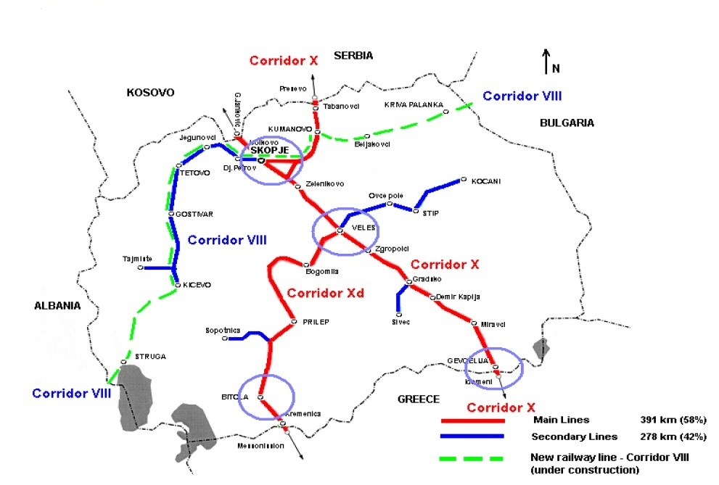
Illustration 2: Railway network in Republic of Macedonia

Just as the road network, the rail network in the country also follows the Trans- European networks. The railway network is composed of one track railroad with train traffic in both directions. The total length of the network is 925 km, of which:
  - Open line 699 km
  - Terminal tracks 226 km
  - Industrial tracks 102 km

Condition of the Rail Infrastructure along the Corridors VIII and X

The railway line along the Corridor X and branch Xd, is 215 km long and starts from the border crossing Tabanovce in the North and ends in the South with the border crossing Gevegelija, including the branch Xd of the Corridor X that starts in Veles and ends at the border crossing Kremenica by Bitola. The railway connection along the Corridor X provides for speed of 100 km/h, and at some points the speed is drastically limited. Taking into consideration that large proportion of the transport is performed on the Corridor X, special priority is given to the increase of speed on certain sections to 130 km/h and to improve the level of infrastructure, with an aim to achieve technical conditions on a level of a Corridor.

The railway line along the Corridor VIII is in total length of 315km, whereas only 50% of the railway line has been constructed so far. At the moment, Republic of Macedonia does not have railway links with the two neighbouring countries, namely Republic of Albania and Republic of Bulgaria. The Eastern part of the Corridor VIII towards Republic of Bulgaria requires another 89 km to be built (29 % of the total), while in its Western section towards Republic of Albania another 70 km is needed (21 % of the total). Railway line along the Corridor VIII is in total 156 km existing link.

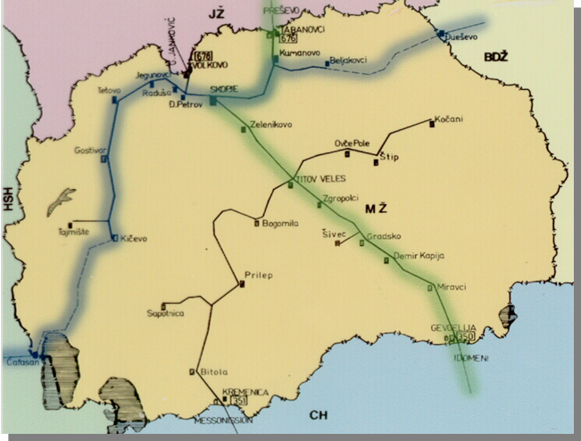

Illustration 3: Rail infrastructure along the Corridors VIII and X
_ _ _ _ _ Missing rail links with neighbouring countries
_________ Existing rail links

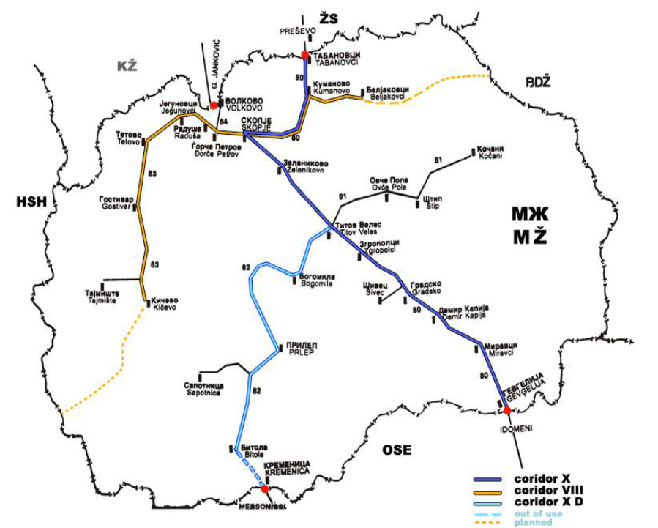
Illustration 4: Railway infrastructure. The gauge of the entire network is 1435 mm.

The main line of Corridor X runs from Tabanovci to Gevgelija alongside Skopje and Veles and is electrified, 312 km of tracks with a single - phase system of 25 kV/50 Hz. Corridor X d runs from Veles to Bitola and beyond to West Greece) is served by diesel powered trains up to Bitola. The track from Bitola to Kremenica will be reconstructed as part of project with the IPA I-OPRD 2007-2013.

Corridor VІІІ was confirmed as an integral part of one of five new Trans-National European axles: the South- East axle. Also in the context of the Euro-Asiatic transport links Corridor VІІІ was identified to connect Europe with Asia, the Middle and far East to the Balkans and Turkey with both railway and road infrastructure. Currently there is an ongoing the process for development of Rail Corridor VIII. The missing links towards Bulgaria are planned for construction and to be operational by 2022.
Other domestic rail links are supportive to the main international corridors. These include tracks from Skopje stations to Kosovo* and from Veles (Eastbound) to Shtip and Kocani.

Border crossings

There are 3 rail border crossings: 2 with Serbia and 1 with Greece.

The border crossing issue is depending mainly on the successful implementation of the modernization of customs regulations, improvement and operability of the cross border buildings, enhancement of the battle against smuggling, corruption and illegal human trade. These border crossing issues are seriously hampering the operations of trucking and railways. At the borders, the railway companies have to change locomotives and staff.

Republic of Macedonia is making efforts to make “one stop shop” on the rail network with the neighbouring countries but due to political constrains there is only one active agreement and that is with Kosovo. The preparatory activities for concluding similar agreement with Serbia are ongoing.

Multi-modal transport is a logistics concept that places the legal liability for the movement of goods by several modes on a single operator. An overall regulatory framework that permits the licensing of multi-modal transport operators will be a challenge for the near future.

Traction and Rolling stocks

Currently there are 56 locomotives, 124 passenger cars, and 1553 freight wagons. For improving the need of providing service for the carriage of passengers and goods in the rail transportation, there is a Project for renewal of transport fleet for passengers and supply of 150 wagons of different types of freight transport. With realization of this project, it will be purchased: 4 diesel engine passenger; 2 three- passenger electric motor gaskets; Reconstruction of 5-6 electrical locomotives (including reconstruction of buildings where vehicles are maintained in terms of energy efficiency); 150 freight cars of various types and also until 2016 a purchase of another 150 passenger wagons are planned to be completed.

On the issue of the Rolling stock safety, Directive 2004/49/EC states that national safety authorities are responsible for the authorization of existing rolling stock. Rolling stock may be put into service only if it is designed and constructed in such a way as to meet the essential requirements concerning the sub-system. The rolling stock safety is prescribed with RIV and RIC (international regulations) and the Law on safety in the railway system (the national legislative), which are mutually coordinated and regulate the way of the technical inspection of the rolling stock, their maintenance and use, the way of pulling the brakes of the vehicles, equipment of the vehicles with automatic and manual devices for pulling brakes. With by-laws which arise from the Law on the composition of the trains, the number and schedule of the vehicles in the trains, the way of executing the inspection of the correctness of the brakes, handling and maintenance of the vehicles separately and the vehicles included in the trains are elaborated in details.

Rail safety

The Administration for safety in railroad system (whitin the Ministry of Transport and Communications) as competent authority for rail safety system ensures the development and improvement of the safety rail system, collects information on common security indicators through annual reports from the security authority, infrastructure manager and the carriers. The common security methods serve to estimate the level of safety and security of the goals achieved, and implementation of other security requirements. Common security objectives define the level of security needed to reach certain parts of the rail system and the system as a whole. Manager of infrastructure and the carrier separately made, down and organize system security management in order to ensure that the rail system can achieve common security goals.

The safety of railway infrastructure is laid down in Law on the Safety of Railway system, Law on Railway system and by-laws which sets conditions, measures, records on protection in the railway infrastructure which provided legal, technical and physical protection, protection and supervision of real estate.

The safety in the rail transport system as set in the National transport strategy remains a priority of the Government of the Republic of Macedonia. Under the current IPA I assistance (2007 – 2013) there is an ongoing project for supply and Installation of Equipment for European Train Control System (ETCS level 1) and Global System for Mobile Communications-Railway (GSM-R) along the Corridor X. The role of the Global System for Mobile Communications-Railway (GSM-R) along the Corridor X (Tabanovce – Gevgelija) is to enable exchange of voice and information between the control room and train, including too signalization information to the train master and also to provide increased accuracy, capacity and speed of the trains along with the higher safety level. The European train control system (ETCS), as part of the European rail traffic management system (ERTMS) enables automatic speed control of the train according to the characteristics of the rail network and signalization and directly influence on the traffic safety excluding all the possible train driver errors and disrespect of the signalization. European system for speed control of the trains is a system that not only allows speed limits to be transmitted to the driver, but can also continuously monitor the driver’s response to this information. An on-board computer effectively compares the speed of the train with the maximum permitted speed and automatically applies the train’s brakes if it exceeds the limit. The implementation of these two systems will have direct affect on the improvement of the safety of the rail system.

However, continues efforts are going to be made in the forthcoming period as well for increasing rail safety with improving signaling equipment on the collision spots, implementation of the security measures on the cross sections with the roads and improvement of the railroad level crossing.

Investment in the rail sector

The construction, reconstruction, rehabilitation and modernization of rail infrastructure along the SEETO comprehensive network, with a special emphasis on the improvement of rail safety and railway electrification and making rail a competitive and attractive mode of goods and passengers transportation is a long and expensive process. Main risks can be summarized to lack of financial resources to implement the projects, lack of maintenance plans and financial resources allocated to this, lack of commitment by neighbouring countries to implement the SEETO and TEN-T agenda.

There are currently projects for improvement of the rail infrastructure in the Republic of Macedonia such as rehabilitation of railway stations, rehabilitation of rail sections, projects for increasing the speed, electrification and operational aspects of the rail but still there is still room for improvement.

There are investments along the Corridor X in the period from 2012 – 2014 with an overhaul of a total length of 54 km of three sections: Tabanovce – Kumanovo, Miravci – Smokvica, and until the end of 2014 will be completed an overhaul for the section Nogaevci – Negotino. However, this is not sufficient to make rail competitive over other means of transportation. As the data in the show in the Table 1 and Table 2 below, the relative share of the railway transport both in terms of passengers carried as well as in terms of transport performance is about 9%. The average transport distance of international trips by rail is very low (87.2 km. This means that despite the positive trend as outlined in the tables below, the actual market share of the railway transport from all intercity trips is much lower.

The strategic goals of the government in the field of rail transport are:
- Attractive passenger transport by rail by providing high quality commuting services, safe transport options and guaranty that passenger’s’ choice of transport takes into account the environmental aspects, including air quality and noise emissions.
- Support of heavy freight trains carrying a number of different products with an effective transshipment from rail to road transport and vice versa.
- Support of national industry in providing cost effective and efficient mode for mass transportation.

While assessing the potentials for development of railways in future, one should not overlook its advantages over road transportation. Railways represent a significantly less burden on environment. The land used for railway construction is significantly smaller than the land required for construction of highways. Railways transportation is also significantly less air polluting and needs less energy per unit of services performed. Second, safety on railways is much better than in road transportation sub-sector. These advantages, together with cost efficiency arguments, bode well for an intensified railways development in the country.

Road Transport

The Road Network
According to the Law on Public Roads, the road network administratively is divided in national, regional and local roads. National and regional roads are under state responsibility (generally referred to as the main road network), and the local roads are under municipal responsibility. The national road network is of the highest administrative classification and importance as it is in concordance with Trans National Axes (Corridors VIII and X) and other important international links. The regional road network is of less administrative importance as it interconnects with the national road network and is of crucial importance to the municipalities.

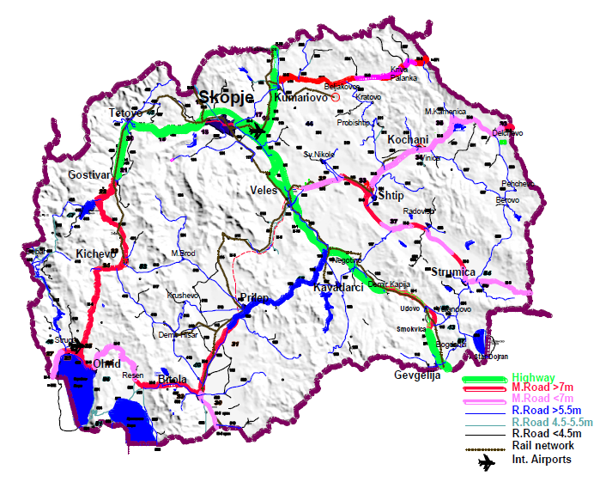
Illustration 5: Road Network of the Republic of Macedonia

The national road network consists of six (6) roads (A-1 to A-6). Most national roads consist of two traffic lane carriageways. Two of the national roads are in concordance with Trans National Axes (Corridors VIII and X) as well as European road network, A-1 (E-75) and A-2 (E-872) are in concordance with Corridors X and VIII respectively. Other national roads form part of important international links, for example, A-3 (E-65), A-4 (E-65), A-5 and A-6.

Traffic counts take place either on road sections upon one of the motorways (national network counts - automatic or manual), or upon regional road segments (regional network counts - usually manual).

As in many other countries, the road transport in the Republic of Macedonia has the largest share, both in freight and in passenger transportation segments. In the structure of the freight transport, domestic traffic dominates the international and transit ones. In a similar way, the relative share of the road passenger transport exceeds the share of rail transport. Data on number of passengers transported by intercity public transport modes for period from 2003 to 2011 are presented in the following table:

Table 1: Passengers carried in intercity and international traffic

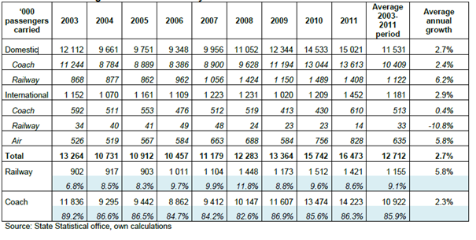

Table 2: Passenger intercity and international transport performance
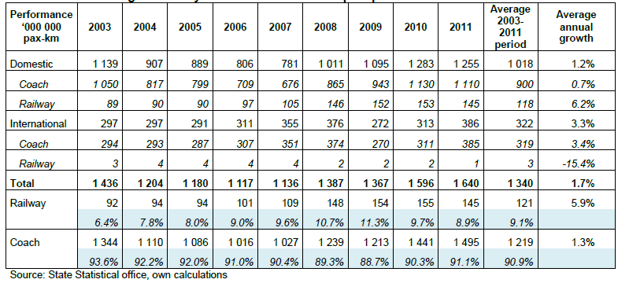

Intra-country transport dominates the road freight sector while the remaining is distributed between international transport and transit transport. From the data above it is evident that:

- Over 90% of the overall transport performance belongs to the coach (and air) transport.
- The average transport in international trips by coach compared to distance of international trips by rail which is very low
- It should be noted that the above data refer to the public transport only (excluding the lake transport), i.e. trips by car are not taken into account in the calculations.

Condition of the Road Infrastructure along the Corridors VIII and X
Corridor X is the most important element of the core transport network, linking from Greece to Austria. Present average annual daily traffic of 15,000 is set to increase at 6% per annum to over 20,000 and to 40,000 by 2020. The E-75 is mostly four lane tolled motorway. A high proportion (25%) of it is regional or international. Within the national territory, the relevant part of the Corridor X is in concordance with National road A-1 (international mark E-75), which crosses the territory in direction North-South.

Concerning the construction of road infrastructure along Corridor X, of the 172 km long Corridor X passing in the North – South direction, 83% has been already constructed at modern highway standards with the remaining 17% are under construction. Until 2016 the Corridor X will be on motorway standards in the full length of the territory of the country

Corridor VIII spans over the South Eastern European area where transport infrastructure is traditionally weak. It connects the Adriatic with the Black Sea. Corridor VIII is a multi-modal transport system along the East-West axis comprising sea and river ports, airports, multi-modal ports, roads and railways, with a total extension of 1270 kilometres of railways and 960 kilometres of roads. In view of future planning for the extension of the Trans-European Transport Axes it is of common interest of all the countries of the region to consider Corridor VIII the Motorway of the Sea connecting Varna/Burgas, Sofia, Skopje, Tirana, Durres to Bari/Brindizi in Italy (the Black Sea with the Adriatic Sea). Corridor VIII is passing through the national territory from East to West with a total length of 304 km. concerning the road infrastructure along the Corridor only 37% are on motorway standards.

Border crossings

The government considers the border crossing points located on the Corridors VIII and X to be strategic border crossing points, whilst others are classified as regional and local border crossing points.

There are different stakeholders in charge for the border crossing controls on the road border crossing points, such as Custom service, Ministry of Interior and other related inspections. Up to now when considering the peak traffic flows in the summer period and around end of the year, there has been proven that the various institution have excellent coordination and cooperation among themselves in order to cope with the challenge and facilitate efficient border crossing.

Moreover, Custom services in the recent years have invested in modernizing border crossing services with providing x-rays scanners for more efficient fright control at the border crossing points, with greater frequency and electronic exchange of documentation.

Road safety
Each accident – particularly where serious injuries or deaths result – is a personal tragedy and has a major impact on productivity and implication in the health sector. In Republic of Macedonia 51.5 accidents happened each day, of which 11.4 accidents with injuries. The average number of persons killed per day is 0.39, the number of seriously injured 3.0, and the number of people with light injuries 8.3. The official estimated cost of accidents to the economy was about 1.5 million euro, not taking into account the cost for recovery, permanent invalidity or death.

The full range of road safety measures are covering:
- Enforced Road worthiness of the vehicles and security equipment,
- Improve Driving skills & responsible behaviour,
- Stricter Law Enforcement
- Improve Road infrastructure safety and
- Implement Road Safety Management.

The Government is politically and financially committed to reduce the death toll on the roads by 50% within a period of 10 years. This is in line with the goals set in the EU White Paper on transport from 2011 which sets the goal for moving close to zero fatalities in road transport by 2050 and halving road casualties by 2020.

The State Security Council on Road Traffic developed the National Strategy to improve road safety in 2009 - 2014 and it was adopted by the Assembly on 11.11.2008. In November 2009 the Government of the Republic of Macedonia established a coordinating body for the safety of traffic on roads in the country, chaired by the Deputy Prime Minister of the Republic of Macedonia. Coordinating authority is responsible for monitoring of the implementation of the National Strategy to improve road safety in 2009 - 2014.

The Government will continue to work on improving the safety situation across all transport modes with safety standards orientated towards EU best practices. Safety and personal security concerns associated with transport will be addressed in order to improve quality of life. The Government will as well encourage participation by any road users and from those that are affected by transport in the design of new safety regulations and monitoring. Efforts are going to be made for a further alignment in the area of road safety with the Road safety directive.

Road vehicle safety measures in the national legislation are defined as follows:
- Every road vehicle needs to be registered and to meet the current legislation regarding technical conditions, equipment and accessories.
- In the case of special transport equipment, the vehicles also have to meet the requirements regarding dangerous good (ADR) and perishable goods (ATP).
- Motor Vehicles and trailers have to meet the countries’ homologation regulations and / or being in line with the ratified international agreements.
- Enforce the compulsory use of active and passive vehicle security devices.
- Implementation of EU best practices guidelines on securing cargo and special transport.

Regarding the behaviour on the roads, every citizen is supposed to abide to the law, respect of speed limits and avoiding driving under the influence of alcohol, drugs or medicines that affect people’s driving ability. The aim is to reduce the death toll & severe injuries. The policy towards defensive driving includes special educational programs and tougher restrictive measures. To positively influence the attitudes and behaviour of road participants, the following initiatives are taken into consideration:
- Enforcing the existing traffic rules and criminalize road rage;
- Revise the current legislation on issuing Drivers Licenses;
- Cooperating, coordinating and co-funding with relevant partners specific Road Safety Campaigns
- Improve training and education of road participants
- Enforce and monitor efficiently driving and rest periods of professional drivers
- Reducing road rage and set speed limits in residential and school areas.

There are continuous public campaigns for road safety financed from the State Security Council on Road Traffic and the Ministry of Interior for arising public awareness and behaviour on the roads.

Secure road infrastructure is contributing substantially to reducing accidents. The "self-explaining road"-concept is to influence and guide the driver's behaviour. Road infrastructure has to provide safe and continuous traffic flow on all public roads in the country. This could be achieved with measures such as:
- Harmonization of signs and road markings in line with EU best practices.
- Improving the tunnel safety measures (exceeding 500 meters of length) aligned to the European proposed safety standard.
- Introduce binding Infrastructure Safety Management Measures for contractors and road authorities in all stages of planning and execution.
- Improving security standards on Road-Railways crossings
- Eliminate bottlenecks and black spots wherever possible
- Proper and efficient road maintenance
- Ensure visibility on the roads by eliminating physical and illegal obstacles

With an IPA I assistance under current period OPRD 2007-2013, it is foreseen implementation of a project for preparation of a study and action plan for improvement of road safety along SEETO Comprehensive Network. Though the CENSOR (South East Neighborhood Safe Routes financed from the ERDF), project where the Ministry of Transport and Communication and the "Drivers Association of Macedonia" are partners, a survey was conducted of the roads conditions using EURORAB methodology. Final recommendations from CENSOR project and the study for improvement of road safety along SEETO Comprehensive Network are going to be taken into consideration to implement measures for increasing road safety along the Corridors in the period 2014-2020.

In order to increase safety on road infrastructures, the Government of the Republic of Macedonia makes efforts to introduce a Road Infrastructure Safety Management system in the forthcoming period focusing on:
- Road safety impact assessments
- Road safety audits
- Network safety management
- Safety inspections by the competent authorities
- Traffic Information System
- Introduction of an integrated road management systems, which includes:
- Vehicle classification, surveillance and detection systems from tunnel management, vehicle classification systems and video surveillance to automatic incident detection, meteorology stations, road infrastructure protection, wide-area alert systems, disaster response and recovery systems, road winter maintenance system.

Concerning the implementation of the Road safety audit, the State Security Council on Road Traffic financed by World Bank loan agreement is strengthening the administrative capacity in this area.

The Government, in the coming period envisages implementation of Intelligent Transport System on Corridor X, which will have an impact on the safe management of the road system and safer roads for the users.

Air transport

Two airports are in operation in Republic of Macedonia:
a) Skopje international Airport and
b) Ohrid International Airport

The Skopje airport is the main airport with connections to international destinations. It is connected by road via de А1 (Corridor X). The airport is given under concession for a period of 20 years to T.A.V. Airports, Turkish Corporation. Airport "Alexander the Great" - Skopje is near the crossroad of the Corridor "NorthSouth" (E-65 and E-75) Corridor and East-West "(E-850 and E-871) (fig.m 01). Thus, it has very good location to become an important logistics and transport junction, not only for the country but for the entire Balkan region as well. Ohrid airport is primarily a tourism oriented airport and is connected by road to the A3. Airport St. Paul the Apostle "- Ohrid near the south-western edge of Corridor East-West" (E-850 and E-871), near the border with Albania (fig.m 01): This airport would have good access to the Adriatic Sea through Albania to Montenegro and Croatia.
Illustration 6: Map –Airport in Skopje and the connections between Skopje and Ohrid

The table below shows the distance from the Airport in Skopje to the main logistical and industrial destinations in the region

Destination | Distance (km)
Belgrade | 420
Sofia | 250
Tirana | 230
Thessalonici | 230
Athens | 700
Zagreb | 815
Prishtina | 90
Saraevo | 450
Source: http://www.airports.com.mk/cargo_CargoCentre.htm

Development of air transport contributes to the economic growth of Republic of Macedonia. Moreover, a modern and reliable aviation system will help the country to reach its goal of European Union integration through both the utility of the system itself and positive growth effects that can be derived from increased transport. There are several projects that should be implemented in the short to medium term in order to meet the increased amount of traffic and the needs of passengers, these projects include:

- Increase in capacity,
- Full compliance with ICAO standards,
- Creation of accessible facilities and services,
- Adaptations for handling of passengers of restricted mobility,
- Upgrading Car Parking Facilities,
- The improvement of Access to and from Airports
- Providing additional land to deliver the future needs of airports and
- Upgraded road and urban transport in general, the connection of the main airports service areas.

Full membership of Republic of Macedonia in JAA - Joint Aviation Authorities
Aviation officials of the European countries of ECAC (European Civil Aviation Conference) in 1970 formed the association body of ECAC under the name JAA - Joint Aviation Authorities in order to develop high safety standards for aviation in Europe. Aviation Authority of the Republic of Macedonia was established in 1993 as the Directorate for Civil Aviation. Directorate and became a candidate member of the JAA in 1999, while it applied for full membership in 2002. The Republic of Macedonia has received an invitation to acquire full membership in JAA at meeting of the Board of Directors of the air authorities of the Member States of the JAA, held on 12.03.2008 in Paris, France, with which the Civil Aviation Agency officially became a full member of JAA. With this, the country fulfilled one of the most important obligations under Protocol V of the multilateral agreement for establishing the European Common Aviation Area with the European Union.

Inland waterways

The access to the neighbouring ports is established through the roads and railway links. Passenger transport exists only on Ohrid Lake with smaller ships from 25 to 150 seats. At the moment there are no special stations for gas supply of the vessels.

There are two types of passenger transport on the Ohrid Lake: Line and out-of line transport by agreement between the gondolier and the users of transport. Line transport is carried out on a certain route and by previously set schedule of sailing, and non-line transport is often used for night cruises for transport by boat to a group of passengers who have the same final destination.

Lake traffic plays an important role and an important potential that can greatly contribute to the overall planned development of the Ohrid region. Water traffic on the Ohrid Lake has great potential and there are good preconditions for its development. Its development should also contribute to meeting the objectives of building a sustainable transport system in the region, if it succeeds to attract a greater number of trips. The next image shows the lines proposed in lake transportation lines, the current (black squares) and proposed new ports (purple circles) in the future should be built.

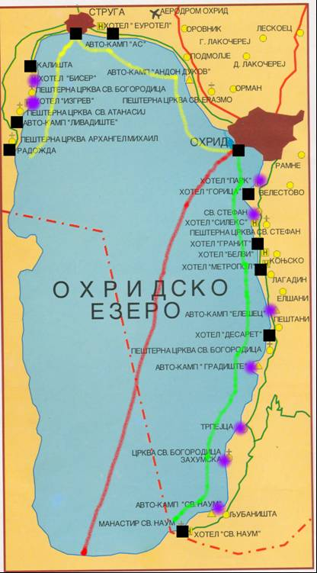

Urban and green transport

The transition economies combine rapidly increasing motorization with a rapidly declining fiscal capability to support public transport systems and improving transport infrastructure. This has generated differences between social and economic development of cities, particularly identified through a greater role in shaping land use.

The National transport strategy defines priorities for urban transport development which are aimed towards:
- Improving the movement of people rather than improving the movement of motorized vehicles.
- Ensure safe, affordable, quick, comfortable, reliable and sustainable access for the growing number of city residents to jobs, education, recreation and other needs in accordance with the National Transport Strategy.
- The focus will be placed on country main urban areas with a population more than 50.000 inhabitants.
In accordance with the Law on Local Self Government and Law on City of Skopje, municipalities at a local level have the competencies over urban transport development.

However, considering that the Capital Skopje is populated with around 40 % of the urban population, the Ministry of transport and communication undertook measures in order to support development and improve the urban transport systems using buses, in accordance with the European emissions legislation in the capital. In 2012, the project was completed for supply of 313 new buses, providing to the citizens, comfortable, modern and safe public transportation. The investment is in total of EUR 50 million financed from the national budget. Additionally, city of Skopje is implementing activities for improving conditions of city bus sTSOPs with replacing the old and ruined constructions with modern 226 new bus stops in a total value of EUR 1.07 million from the own budgetary resources.

There are measures implemented in relation to the parking organization nearby key points of the mass public transport as construction of new parking garages by private investors, providing new 1384 parking places and by the national funds, providing new 1686 parking places in the central area.

The municipalities with own budget resources are undertaking continues activities for construction, reconstruction and rehabilitation of pedestrian lanes, alleys and sidewalks, bicycle lanes, including related activities such as installation of signs, markings as a part of the integrated urban transport system.

However, Ministry of transport and communication, in the past period with own budgetary resources supported urban infrastructure development and constructed 78km of pedestrian lanes and 2km bicycle lane with total value of EUR 1.4 million in the Municipality of Dojran Veles and Krusevo.

In the period 2014-2020 we shall continue to pursue the goal for greener urban transport in the cities in the country.

Socio-economic analysis (including SWOT analysis)

One of the key factors to pursue economic growth is to establish and improve the transport and environment infrastructure, as prerequisites for sustainable development.

Underdeveloped infrastructure inhibits from the sustainable development of the economy, or the development is inadequate and at the prejudice of the environment deterioration and health of population. The key socio-demographic and economic factors that influence changes in transport demand (and that in turn influence the rate of transport developments) are population growth, gross domestic product, motorisation growth, tourism, agriculture and industry. High quality transport infrastructure is necessary to support the growth of the external trade activities and to increase mobility of individuals with neighbour countries and the EU.

The population growth rate is relatively low (0, 3%) and it influences economic activity levels that in turn influence the growth of consumer demand. The process of migration to a market-based economy is now established and irreversible. This gradual process should generate higher economic growth in future years, which in turn should generate an increase in demand for transport services. The major export destinations for agricultural products are Serbia, Kosovo, Montenegro, Greece and Germany.

Continuation of the national investment policy and IPA I assistance under Operational Program for Regional Development 2007 – 2013

Based on the principles of developing the Transport corridors – Axis in the previous programming period the Operational Programme Regional Development-OPRD, was prepared as a multi-annual program, firstly for three year period 2007-2009 and twice extended for periods 2010-2011 and 2012-2013, respectively. OPRD 2007-2013 streamlined the EU assistance into the general framework of the country’s development and ensured that both the national and EU development priorities and policies are respected. The OPRD programme strategy embraced the period 2007 – 2013, with financial indications in the transport sector of EUR 109 million (18% of the total envelope). On rail infrastructure were allocated EUR 31 million and on road infrastructure were allocated EUR 78 million.

The Operational Programme for regional development 2007-2013 reflected the guideline principles of the Commission’s Multi- annual Indicative Planning Document (MIPD) which was the strategic document for IPA. It also directly related to the priorities set out in Strategic Coherence Framework (SCF) which is the basic instrument for programming of pre-accession assistance from the EU through the IPA’s component III (Regional Development). The programme strategy embodied in this Operational Programme is fully consistent with the strategic priorities and is compliant with the Community Strategic Guidelines for Cohesion 2007 – 2013 and with other documents governing EU principles of sustainable development and with regulating external assistance.

The strategic objective of the OPRD 2007-2013 was to support the conditions for sustainable development through the improvement of the transport infrastructure. In particular, the objective was focused on upgrading and modernisation of the road and railway infrastructure along the Pan-European Transport Network (Corridors VIII and X). The above objectives are achieved through the various defined priority axes and their measures. The OP has defined four priority axes:
- Corridor X Motorway Completion
- Upgrading and Modernization of the Transport Infrastructure
- Improvement of Environmental Infrastructure
- Technical Assistance

The measures are focused on upgrading and modernisation of roads and railways, whereby the implementation of one major road construction project along Corridor X. Important attention has also been given for the preparation of new projects that will form a pipeline of eligible projects in the transport infrastructure development. The created pipeline formed a sound basis for the implementation of the priorities in the forthcoming programming periods.

During the preparation of the OPRD 2007-2013 the main problem was a serious lack of project documentation for further implantation of the projects and one of the goals archived was the development of project documentation in order to be able to implement project and realise the goals.

In this context the project Support in identification, assessment and selection of eligible projects for IPA Regional Development Component – part Transport has been implemented back in 2011 under the fourth priority axis of the OPRD 2007-2013 which gave a clear picture in the road and rail transport infrastructure, creating an indicative list of projects and action plans for investments and thus formed a sound basis for the implementation of the transport infrastructure priorities in the forthcoming programming period. The study was prepared on basis of the Multi-Criteria Analysis (MCA) and analyzed 15 projects for the rail sector and 22 projects for the road sector with time frame of 10 years. The national transport strategies and priorities were thoroughly presented in this operational programme.

The defined priorities in the Sector Operational programme on Transport for implementation of IPA II assistance are fully compliant with the priorities determined in the national strategic documents and particularly with the National Transport Strategy and the national Public Investment Programme. Regarding the regional approach it is noteworthy to mention that the priorities of the Sector Operational programme on Transport contribute to the development of the Core Network in the South East Europe as determined in the Five-Year Multi-annual Plan of SEETO.

Taking into account the projects implemented under the OPRD 2007-2013 and the investments (projects) financed by IFI’s, the state budget and other institutions, the state of play of project on the SEETO Comprehensive road and rail network is as following:

TOTAL investments ROADS on SEETO Network
- Completed investments in the period 1990 -2014 are EUR 340 million.
- Planned and ongoing investments for 2014-2019 is EUR 780 million.

Total investment on RAIL on SEETO Network
- Completed investments in the period 1990 -2014 is EUR 7 million.
- Planned and ongoing investments for 2014-2022 is EUR 550 million.

Total Transport investment on SEETO Network
- Completed investments in the period 1990 -2014 are EUR 347 million.
- Planned and ongoing investments for 2014-2020 EUR 1.3 billion.

SWOT Analysis

The location of Republic of Macedonia is favourable and places the country at the crossroads of East and West and is a transit route for traffic between Central Europe, the Aegean Sea, the Black Sea and the Adriatic Sea. This can be categories as strength or an opportunity.

Due to historic and political relations in the past, the transport connection from north south was the main axis which was pursued and developed. This is natural and logical knowing that Albania was until the 1990’s a closed country and Bulgaria was part of the Warsaw pact. The Socialist Federal Republic of Yugoslavia was developing the north-south connection. This is the main reason why the favourable geographic location of the Republic of Macedonia was not materialised in the previous period. This can be characterised as a weakness.

After the independence in 1990 and the difficult transition from planned to market economy the investments in transport sector were decreeing (in some cases not even funds for this were available). With the relative improvement of the economic station (when growth rates are positive) the investments in transport are more increasing and what is known as the 3 - I for growth “Investments, Infrastructure and Innovation” are rolling on.

In 2007 the first National transport planning document was adopted which was the National Transport Strategy (NTS) for the period of 2007-2017. Operational Program for Regional Development (OPRD) was also adopted in 2007 covering the period 2007 -2013. The OPRD and NTS are complementary and strive to achieve the same goals. The goal is to have better connectivity with the EU members, better connections with the neighbouring countries.

The implementation of this goal will lead to a better integration and cohesion of the whole region to the EU and will contribute to the goal of achieving a single European market. The investments on the developing the main transport axis north – south and east west are the main focus. The logic and the rationale is that due the above mentioned the there is a serious need for investments in developing these axis. These are the main arteries in the Republic of Macedonia which have the highest traffic volumes.

The sector approach which aims as the transport system as whole is fully supported, but should also be tailor made for each county and serve the real needs deriving from the transport sector. Republic of Macedonia is a country “in the middle” and will peruse development of the transport system as a whole, but with a specific priority towards streamlining the investments where they are needed.

In setting out the medium-term needs and objectives of the Sector Operational programme on Transport, the socio-economic analyses have been supported by the SWOT analyses to analyse the transport sector in details, to better justify and address the objectives of the operational program and to set out the strategy, how to achieve the objectives.
Table 1 – SWOT analysis of the Transport Sector
Strengths | Weaknesses
Excellent geographic location along main Balkan international routes  Dense and extensive road network connecting the main populated areas  Acceptable condition of main road network, with already existing high speed segments  Developed education system related to transport and civil engineering qualifications  Developing road transport services  Modern legal framework in course of implementation for all modes of transport, progressive integration of the EU acquis in the transport sector  Pipeline of transport sector projects prepared for implementation  Active participation in regional cooperation activities (including the South East Europe Transport Observatory-SEETO) to support project development and a more regional approach for transport infrastructure development | Limited network’s connection of rail and road with neighbouring countries  Insufficient number of transport connections in the main transport corridors (TEN-T)  Poor condition of the railway infrastructure negatively influencing the speed and travelling comfort as well as attractiveness of goods transport  Limited capacity to support national PSO in the rail sector.  Backlog in maintenance of rail infrastructure  Cross border delays  Limited quality and array of services in road operations  Unsatisfactory level of financing of road maintenance  Insufficient founds for innovative technologies and research activities  Low level of road safety  Low quality of railway services and difficulties with railway financing  Lack of connection between different transport services and between different transport infrastructures (intermodality, multimodality), absence of logistic centres
Opportunities | Threats
Programmed access to EU pre-accession instrument for the development of infrastructure  Coordinated regional IFI policy for transport project alignment favourable to projects in the Republic of Macedonia  Development of transport service for international passenger mobility  Development of logistics activity supporting the growing interior market  Development of transport demand for intercity connection, potentiality of development of some public transport service network  Support of the transport services for the development of trade relations with the EU, especially in long distance rail transport mobility  EU recognises that the importance of Trans-European Corridors VIII and X including branch X-d as trans-national axes and multimodal directions are part of TEN – T | International financial support is not at the expected level  External trade is hampered by transport bottlenecks  The EU legal framework is formally adopted but not fully implemented in the field  Alternative transit routes are preferred by shippers  Interior economic demand weakness  Strict rules and procedures for implementation of EU funded programmes

Scope for a sector approach

The Sector Operational programme on Transport is implemented through a sector approach. The below text provides a short overview and a more detailed description of the various constitutive elements of the sector approach.

Various important elements such as the sector policy framework, the sector policy dialogue and the consultation and monitoring mechanisms need further development. For this purpose the Government and the Commission will work together and agree on a roadmap that will define the main challenges, the activities to be undertaken, the responsibilities and the timelines in order to gradually fulfill the requirements of the sector approach.
The Government and the Commission will also work together and agree on a policy table that will set out the key reforms in the Transport sector over the coming years (including approximation with the EU acquis) and will serve as the basis or the common policy dialogue.
The gradual improvement of the sector framework and the implementation of key sector reforms will be supported by the Commission through this SOP, notably via Activity 3 and the support might take the form of TAIEX, Twinning, service contracts, etc.

National sector policies and strategies

The Government recognises the importance of transport in the current phase of national development. The main document is the National Transport Strategy 2007-2017 which was adopted by the Government in 2007 and the preparation was financed through CARDS program, determining the national transport development priorities for the period 2007-2017. The National Transport Strategy (NTS 2007-2017) foresees the implementation of necessary reforms in the sector in accordance with defined national priorities and obligations arising from the National Programme for the Adoption of the acquis. The Strategy defines the main investment priorities in the sector, taking into consideration the TEN-T network, focusing on construction, reconstruction, rehabilitation and modernisation of the road and railway infrastructure along the SEETO Comprehensive Network with a view to fully connecting the country to the Trans-European Transport axes

Other strategic documents of importance for transport development are:
- Operational Program for Regional Development for period 2007-2013
- Annual Programs for construction, reconstruction, rehabilitation and maintenance of state roads, adopted by the Board of Directors of the Public Enterprise for State Roads;
- Five-years Program for construction, reconstruction, rehabilitation and maintenance of state roads, adopted by the Government of the Republic of Macedonia for the period 2013-2017;
- The National Program for railway infrastructure 2011-2013 and 2014-2016
- Annual Program for rail infrastructure of the "Public Enterprise Macedonian Railways Infrastructure"
- National Strategy for Air Transport 2014-2018
- Program of the Government of the Republic of Macedonia for the period 2014-2018

Institutional settings, Leadership and Capacity

The Ministry of Transport and Communications is in charge of creating and implementing transport policy including national strategies and action plans, inspection and enforcement. The State Transport Inspectorate, the Railway Safety Directorate and the Captaincy-Ohrid, within the Ministry, are responsible for supervising the implementation of relevant laws and rules. Railway infrastructure and transportation are managed by two state-owned enterprises Public enterprise for railway infrastructure "Macedonian Railways" Skopje and Joint Stock Company for Transport "Macedonian Railways Transport" the national road network is managed by the Public Enterprise for State Roads (former Agency for State Roads) and "Public Enterprise Makedonija pat", which in accordance with the Law on Public Roads, is competent and responsible for the protection and maintenance of the national and regional road network in the country. The two airports in Ohrid and Skopje are under concession from the Turkish company TAV Airports for 20 years.

Decentralized Implementation System-D.I.S for management of EU funds is in place since June 2009. Until 2013 there has been no de-commitments concerning the EU funds and 40% of the funds available have been executed i.e. paid.

In the previous period besides the project for strengthening the capacities of the State Transport Inspectorate Contract No.09-42802/1 contracted in 2013, Technical assistance project though CARDS 2006 for preparation of the National Transport Strategy Contract No. 06/MAC/09/102 and also Technical Assistance to the Ministry of Transport on Restructuring of the Road Sector in 2007/2008 Contract No. 06MAC/01/09/104 was engaged.

In the current programming period of IPA I, OPRD 2007-2013 in the JASPERS assistance there is as well horizontal measure envisaged for implementing capacity building measures. As an outcome Road Safety training is going to be organized for all related stakeholders. Additionally, in the course of the project implementation, in order to widen the knowledge and expertise of the administration on the issues of the transport sector development project, related trainings and workshops are organizing. As for example in the frames of the Project for development of a study for Multimodal nodes in the Republic of Macedonia, MoTC together with the Faculty of civil engineering organized transport modelling training for better understanding of the benefits of the multimodal transport development and use of IT tools in transport planning process.

Furthermore, in the frames of particular loans related with the project implementation, there is usually foreseen technical assistance component. For instance, in the new railway loan from EBRD for the second rail section Beljakovce - Kriva Planka, which in the stage of preparation for negotiations, it is envisaged to have a consultants, who will assist to Public Enterprise for Railway Infrastructure in drafting and signing a Joint Network Statement with the Serbia and Kosovo rail infrastructure manager. In the project for construction of the motorway section, Demir Kapija-Smokvica, in the frames of the EIB loan, technical assistance in the process of the project implementation in amount of 1,4 mil. euro is engaged.

Policy and institutional strengthening is considered as continues process. Following the recommendation from the European commission’s Progress report, various instruments on disposal will be explored further such as Twinning and TAIEX instruments, JASPERS assistance, technical assistance provided via loans for further capacity building measures and policy and institutional strengthening.

Sector and Donor Coordination

Coordination is mostly done though inter service consultation between Governmental institutions, meaning that every information adopted by the Government, has to have a positive opinion from the relevant authorities concerned. Public consultations according to relevant national legislation take place for every project during the preparatory phase and all concerned stakeholders, NGO’s are informed for the projects. After the consultations are held the opinions and remarks (if relevant) are taken on board and incorporated in the project documentation.

Donor assistance to the country has decreased over the last years. The EU remains by far the largest donor, with other main EU donors including Germany, the Netherlands, and the United Kingdom. Other principal bilateral donors include Switzerland and the United States. Multilateral donors include the Council of Europe, the Organisation for Security and Co-operation in Europe (OSCE) and the United Nations. The main lenders are the Council of Europe Development Bank (CEB), the European Bank for Reconstruction and Development (EBRD), the European Investment Bank (EIB), the International Monetary Fund (IMF), the World Bank (WB), EXIM Bank and Western Balkans Investment Framework-WBIF.

Government donor coordination is led by the Secretariat for European Affairs, which oversees a general and sector donor coordination mechanism, on the basis of the country's Sector Based Approach. The EU Delegation organises regular donor coordination meetings in the context of the annual IPA II programming exercise, as well as ad hoc donor coordination meetings involving EU Member States, international organisations, other donor organisations, civil society and other relevant stakeholders.

Mid-term budgetary perspectives

According to the plan for the implementation of the Sector Operational programme on Transport 2014 – 2020 there is a steady growth in the period 2014-2016, then in 2017 there is small decrease and then increase again in the period 2018-2022. In the period 2014-2017 investments are focused on road transport and in the period 2018-2022 investments are focused on rail transport.

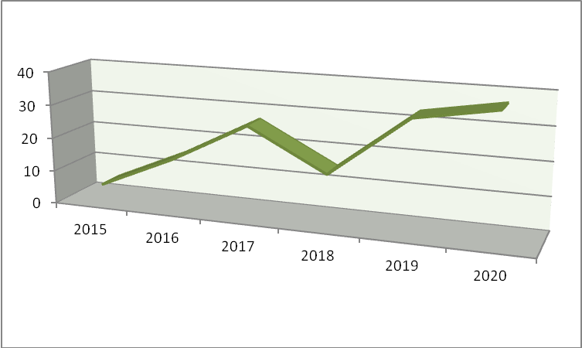

Performance assessment framework

The quantitative and qualitative progress made in implementing the programme as well as its efficiency and effectiveness in relation to its objectives will be measured by the use of evaluation and monitoring indicators related to the results and outputs of the individual measures. The Head of the IPA Unit within the Ministry of Transport and Communications will be responsible for programme monitoring. In this context, this Unit will collect performance data (outputs, results and expenditure) from operations and projects. They will establish, maintain and update the reporting and information system by taking this project-level data and aggregate it to measure, priority axis and whole operational program levels. Data on individuals, who are the ultimate beneficiaries must be collected for each project and used for aggregation at measure and priority level. On this basis the IPA Unit within the Ministry of Transport and Communications will assess the progress of the Operational Program at each level against objectives and targets, prepare reports to the Sector Monitoring Committee, draft the sectoral annual and final reports on implementation and to launch interim evaluations if required. In the context of monitoring and for the purpose of using indicators, the role of the IPA Unit within the Ministry of Transport and Communications will also be to ensure that:
- monitoring requirements are built into the calls for tender and proposals documents (application forms and guidelines for applicants);
- project applications (when appraised and selected) include proposed outputs and results, as well as data on individuals, that are consistent with the OP indicators for the appropriate measure;
- provision of data is built into the contract with beneficiaries as an obligation, and that performance data is provided systematically and in a timely manner by beneficiaries alongside the project reimbursement claim.

The sectoral annual and final reports on implementation will provide information on the use of expenditure according to the above categories.

Public Finance management

Adverse economic conditions affected negatively public finances, as state budget deficit expanded to -2.5% in 2011 from below 1% prior to 2009. Public finances however remain solid. The financial sector was also affected negatively by the worsened business conditions and private credit growth rates declined significantly, but still remain at levels of over 5%.

Unemployment rate has continued its downward trend even after 2009, but still remain at levels which presents and important economic and social challenge. Women remain at a particularly disadvantaged position, where their labour participation rate was just below 45% in 2011, while that of men stood at nearly 70%. On the other hand, high unemployment rates and low activity rates of the women unveil an important extensive growth factor for the economy of the Republic of Macedonia.

Labour, however, is estimated to have had a marginal contribution to economic growth and might therefore provide a considerable source for growth, if certain structural weaknesses of the country’s economy are overcome. Positive prospects for EU accession have also contributed to real income convergence and further integration of the economy of the Republic of Macedonia with the EU.

Macro-economic framework.

Republic of Macedonia is a middle-income small open economy with GDP of EUR 3 600 per capita. Economic growths averaged over 5% p.a. in 2005-2008, but dropped to 1.6% in the past few years. GDP growth slowed down significantly to an estimated 0.5%3 in 2012, but growth prospects for 2013 are favorable, as the economy shows signs of recovery, based on short-term indicators of industrial output and business surveys. While domestic demand had a major contribution to economic growth prior to the downturn, in 2009 and 2010 the weaker performance of imports as compared to exports drove upwards GDP growth. As a result current account balanced improved significantly. External shortfalls narrowed from nearly 13% in 2008 down to 2% in 2010 and 3% in 2011.

The slowdown in economic activity since 2009 had a positive effect on inflationary and current account pressures, but affected negatively the financial and budgetary sectors. Inflationary pressures eased down considerably. Consumer prices declined in 2009 and increased moderately in 2010 and 2011. Current account dwindled as well, but FDI inflows contracted to around 2% of GDP in 2009 and 2010. Still, they increased to 4.5% in 2011. Gross external debt also expanded to nearly 65% of GDP in 2011, among others also due to the decline in GDP. External sector however remained stable, as measured by the coverage of imports with the gross foreign reserves.

Overall assessment

Overall assessment is that investments in transport sector are more than needed and should be streamlined for development of the rail and road SEETO Comprehensive Network as part of the TEN-T Network as presented in the illustrations bellow.

Particularly, the road transport investments should be aimed at further development and modernization of the SEETO Network since these are the roads that have the highest traffic volumes as described in the part 1.3. These investments will complement the investments for improvement of local and regional roads, which is given though loans from the World Bank and European Bank for Reconstruction and Development in amount of EUR 120 million. From the period 2011-2014, 225 local roads in length of 430 km have been reconstructed in an amount of EUR 35 million. Until 2015, 122 local roads in length of 200 km and in amount of EUR 20 million will be reconstructed. Regional roads were reconstructed in the period 2011-2014 in an amount of EUR 28 million in length of 170 km.

Concerning the rail transport, investments are needed further to develop the functionality and operation of the rail network in the Republic of Macedonia considering the missing rail links with the neighboring countries Albania and Bulgaria, since the network is almost 90% on the on the SEETO Network.

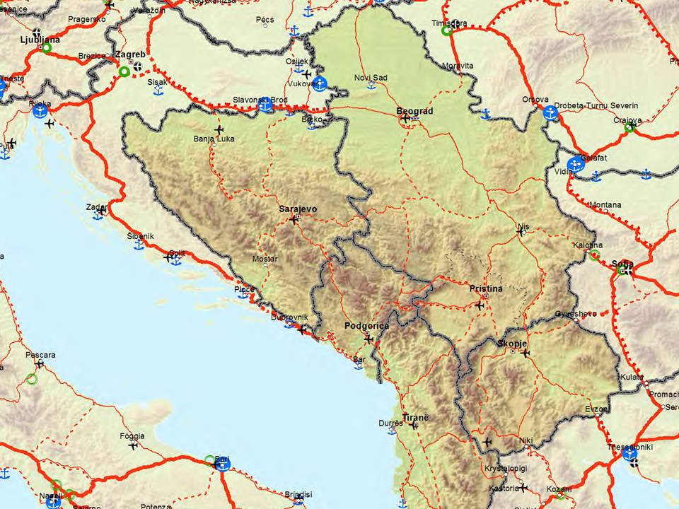

Illustration 7: SEETO Comprehensive road network as part of the TEN-T Network

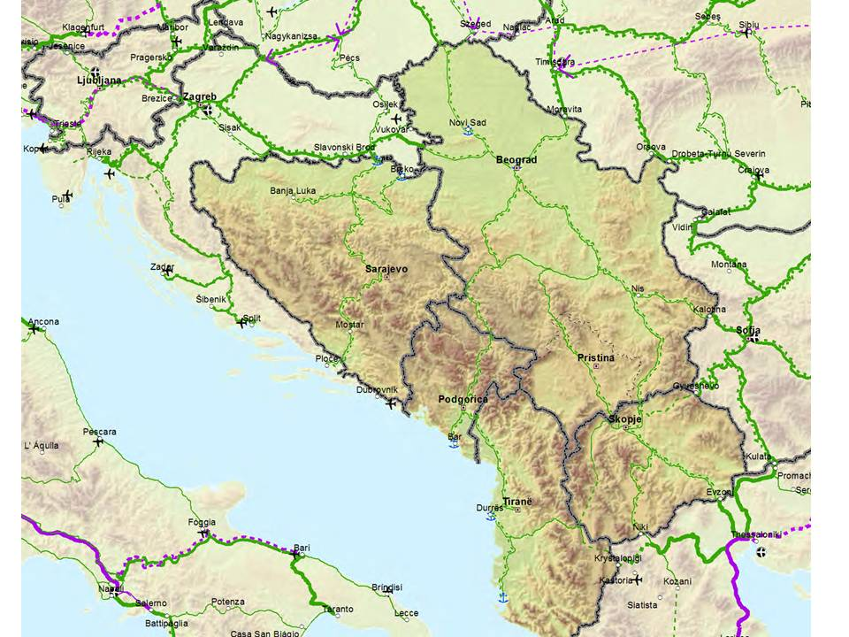

Illustration 8: SEETO Comprehensive rail network as part of the TEN-T

Objectives of the IPA II sector approach

The strategic objective of the Sector Operational programme on Transport for the programming period 2014 – 2020 is to support the conditions for sustainable development through the improvement of the transport infrastructure. Moreover, the objective is focused on improvement of the SEETO Comprehensive road and rail network in the Republic of Macedonia as part of the TEN-T Network (Corridors VIII, X and branch X d). In particular, the objective is focused on improved access and safety of connections with neighbouring countries by upgrading and modernisation of the transport infrastructure along the SEETO Comprehensive Network as part of the TEN-T Network (Corridors VIII, X and branch X d). These actions will be in compliance with European Union standards and are essential in improving the quality of individuals’ lives and for achieving sustainable economic development of the country.

The specific objectives of the Sector Operational programme on Transport 2014-2020 are as follows:
- To upgrade and modernise the transport infrastructure along the SEETO Comprehensive network by connecting national economic centres with Europe and the neighbouring countries
- To promote international and transit movements of people and goods with the EU and its regional neighbours by modernisation and development of the SEETO Comprehensive Network
- To promote sustainable development especially through minimizing the adverse effects of transport on the environment and through transport safety improvement.

Furthermore, the aim of the Sector Operational programme on Transport 2014-2020 is to implement actions, based on lessons learned from IPA I implementation and following recommendation from the Final interim evaluation report on OPRD 2007-20113 (part transport), emphasizing that IPA II uses process of sector approach management closer to Cohesion Fund and Structural Funds management and different than previous EU pre-accession funds. Finally, the aim is to improve the management capacity of the institutions implementing the Sector Operational programme on Transport 2014-2020.

Implementing the Sector Operational programme on Transport 2014-2020 actions will produce direct development benefits such as a reduction in the travel time for passengers and freight, increasing the safety and competitiveness between different transport modes.

The above objectives will be achieved through the various defined priority actions. The Sector Operational programme on Transport 2014-2020 has defined three priority actions:
- RAIL TRANSPORT INFRASTRUCTURE
- ROAD TRANSPORT INFRASTRUCTURE
- HORIZONTAL SECTOR ASSISTANCE

Definition of the strategic priorities creates a framework for the Sector Operational programme on Transport 2014-2020 to ensure achievement of the specific objectives using the assigned Instrument for Pre-accession Assistance-IPA II financial resources for the given period. The priorities are derived from the analyses and the set of objectives, contributing to achieve the objectives and priorities of the other strategic documents as National Transport Strategy-NTS 2007-2017, Country Strategy Paper-CSP, Five Year Multi-annual Rolling Plan of SEETO, Programme of the Government of the Republic of Macedonian for the period 2014-2018 and Pre - accession Economic Programme 2014-2016 (PEP 2014-2016).

The Instrument for Pre-accession Assistance -IPA II is the main financial instrument to provide EU support to the beneficiary countries in implementing reforms with a view to Union Membership. Financial assistance under IPA II pursues the following four specific objectives: (a) support for political reforms, (b) support for economic, social and territorial development, (c) strengthening the ability of the beneficiary country to fulfil the (future) obligations stemming from membership in the EU by supporting progressive alignment with the Union acquis, (d) strengthening regional integration and territorial cooperation.

Sector Operational programme on Transport 2014-2020 is one of the instruments for implementation of the national policy for development of the country and particularly of the national transport policy. Objectives and priorities of the national policy shall be supplemented also by other means, other financial resources, respectively, in accordance with the national sectoral and regional programs and plans.

National Transport Strategy-NTS 2007-2017 present comprehensive plan or action oriented document for implementation of the necessary reforms in the transport sector in accordance with the obligations of the National program for Adoption of the acquis communautaire.

Country Strategy Paper-CSP sets out the priorities for EU financial assistance for the period 2014-2020 to support the Republic of Macedonia on its path to accession. It translates the political priorities as defined in the Enlargement Strategy, and the most recent Annual Progress Reports into key areas where financial assistance is most useful to meet the accession criteria. Also, the Country Strategy Paper sets meaningful and realistic objectives, identifies the key actions and actors, describes the expected results, indicates how progress will be measured and monitored, and sets out indicative financial allocations. The priorities defined for financial assistance will serve as a basis for the (multi-) annual programming of IPA II funds in 2014 to 2020.

The five-year Multi-annual Rolling Plan of SEETO is adopted as a regional strategy for development of the core regional transport network in South East Europe. This plan identifies significant number of regional important reforms and measures for management in the transport sector. The list of priorities covers the whole territory of the participating countries and includes all transport modes.

Programme of the Government of the Republic of Macedonia for the period 2014-2018 sets the set of priorities of the Government for the 4 year period. Since good infrastructure is the foundation for accelerated economic development, better competitiveness of the economy, faster flow of people, goods and passengers, investments in the infrastructure will meet the strategic objectives of the Programme of the Government of the Republic of Macedonia for the period 2014–2018 which is increased economic growth and employment, as a precondition for increased citizens’ standard of living and improved quality of life. Given the fact that Republic of Macedonia is located on the main corridors east–west (Corridor VIII) and north–south (Corridor X, including branch X d), the Government will continue with the realization of the capital infrastructural projects which will contribute to improvement of the competitiveness of the national economy, increased economic growth and will make the regional development steadier. This will intensify the integration towards EU standards and reduce the infrastructural gap.

Pre - accession Economic Programme 2014-2016 presents the priorities and economic policies for next year, medium term macroeconomic and fiscal framework, as well as the agenda of structural reforms. Its goal is to present the activities of the Government of the Republic of Macedonia aimed at realizing the priorities arising from the Accession Partnership of the Republic of Macedonia with the EU, accelerating the economic growth of the country and improving the living standard of citizens.

Operational features of the programme

Geographic and thematic concentration

The geographic location places the country at the crossroads of South-Eastern Europe, making it an important transit route for land traffic between Central Europe, the Aegean Sea, the Black Sea and the Adriatic Sea.

The efforts of the governmental policy are focused on the provision of stability of economic trends, revitalization of economic activities and strengthening of the EU integration processes.

According to the estimated data, the growth rate of the Gross Domestic Product (GDP) in the fourth quarter of 2013 was 3.2%. In this quarter, an increase was registered in most of the sections.

The biggest increase was recorded in sections F - Construction by 32.1%, H - Hotels and restaurants by 4.4% and C+D+E - Mining and quarrying, Manufacturing and Electricity, gas and water supply by 2.6%. In the fourth quarter of 2013, Household final consumption, including Non-profit institutions serving households, increased by 2.4% in nominal terms compared to the same period of 2012, and its share in the GDP structure was 70.7%. In the same period, Export of goods and services increased by 5.2% in nominal terms, while Import of goods and services decreased by 2.3%.

Interaction of the programme with IPA II programmes in other sectors
Based on the principles of developing the Transport corridors in the previous programming period with the Operational Programme Regional Development-OPRD, 2007 – 2013, Sector Operational Programme on Transport 2014-2020 is streamlining the EU assistance into the general framework of the country’s development and ensured that both the national and EU development priorities and policies are respected.

The strategic objective of the Sector Operational Programme on Transport is to support the conditions for sustainable development through the improvement of the transport infrastructure. In particular, the objective was focused on upgrading and modernisation of the road and railway infrastructure along the Pan-European Transport Network (Corridors VIII, X and branch X-d).

Sector Operational Programme on Transport in correlation with the Sector Operational Programme on Environment meaning that the measures, which are implemented in the Transport portfolio have impact on the environmental issues aimed less CO2 emissions and reduction of the adverse impacts generated from transport activities

Complementarity of IPA II assistance in the sector with other donors

Apart of the IPA programme, there are a number of other donor activities aiming to support development of the transport

IFI and bilateral financial assistance to the country is substantial. All major IFIs are present in the field, such as the World Bank, the IMF, the EIB, the EBRD, EXIM bank WBIF, etc. Clearly, IFIs and other donors’ assistance has not only decisively contributed to stabilize and improve the political, economic and social situation in the country but has also complemented the EU association agenda, which is recognized by all members of the donor community. In addition, EU member states as well as other bilateral and multilateral donors also provide significant financial and technical support. One of the projects which clearly shows the complementarity of IPA I assistance in the sector with other donors (in this case EIB and EBRD) is the Major project within the OPRD 2007-2013 in the field of road infrastructure: Construction of New Motorway Section Demir Kapija - Smokvica As A Part Of Pan - European Corridor X.

With IFI and other donor assistance being channeled into many areas the challenges to the programming of EU financial assistance was and is to avoid overlaps and to ensure that different but related activities are aligned. The coordination has improved with initiatives taken by the beneficiary and the large stakeholders.

Equal opportunities and gender mainstreaming

The challenge of cultural differences and providing fair work opportunities for all sections of society is recognized. The equal opportunities must include enhanced integration of women in all areas of the workplace including in the selection, training and development initiatives.

Equality in the freedom and rights of citizens regardless of sex, race, color of skin, national and social origin, political and religious beliefs, property and social status are provided for in the Constitution of the country. Equality between men and women constitutes a basic principle of the international and regional human rights instruments that the country has signed and ratified. There are several positive developments in this field such as adoption of the National Action Plan on Gender Equality, establishment of Unit for Gender Equality within the Ministry of Labor and Social Policy and Gender Equality Commissions at local level. In January 2012, the country adopted the Law on Equal Opportunities of Women and Men with the purpose to promote the principle for establishing equal opportunities between women and men in the political, economical, social, educational field as well as in other fields of social life.

The existence of both legislative and non-legislative measures to fight against discrimination and promote equal treatment and opportunities are prerequisites for EU accession. During implementation of the program measures will be taken to eliminate barriers that could prevent any of these discriminations. Mainstreaming equal opportunities is a horizontal principle of Structural Funds interventions and the implementation of this principle will be considered in the process of implementation and evaluation of the programme.

The principle of equal opportunities is integrated in Transport Operational programme and it encompasses all measures and activities during the period of planning, implementation, monitoring and evaluation that directly influence or contribute to the promotion of equality between women and men, social inclusion and diminishing any form of discrimination. Transport Operational programme supports the establishment of the equality of opportunities for the access to the transport infrastructure as one of the important factor influencing the living conditions and living standard of inhabitants.

Climate action and sustainable development

In the Transport sector, sustainable development will be reflected through the incremental reduction of the adverse impacts generated from transport activities that will occur with the implementation of the Measures proposed. The rail or road activities will be improved for all users through having smoother transport flows and thereby less harmful impacts on the Corridors, their immediate hinterlands and the transport providers and users. The foreseen investments in rail connections will lead to development of the rail as more environmentally friendly mode of transport and will lead to less CO2 emissions by reducing the volume of cargo and passengers transported by road transport.

The opportunity to address sustainable initiatives into the design and implementation of Measures and in the project outcomes will be developed. This will include reference to issues such as:
- Optimal production processes and operational features of the project
- Types and quantities of raw materials, energy and other resources consumed;
- Treatment of residues and emissions by type, quantity, composition and strength including discharges to water and emissions to air;
- Noise
- Vibration;
- Light;
- Heat;
- Radiation;
- Deposits/residues to land and soil;
- Physical Severance
The specific actions will incorporate relevant best practice observance into the design processes and then to incorporate them into the implementation of measures and also in the post-implementation procedures. The implementation of the proposed Programme actions is designed to provide a permanent improvement in the quality and protection of the environment. The actions will positively improve the various qualities both for users and for those living along the Corridors.

Programme strategy – Actions and activities
The Sector Operational programme on Transport 2014-2020 has defined three priority actions:

- Priority Action 1 - RAIL TRANSPORT INFRASTRUCTURE
- Priority Action 2 - ROAD TRANSPORT INFRASTRUCTURE
- Priority Action 3 – HORIZONTAL SECTOR ASSISTANCE

Priority action 1 – Rail transport infrastructure

Aim: The purpose of the priority action is to improve the rail transport infrastructure for better cohesion with the EU member states and regional neighbours, supported by varied investments in the rail transport infrastructure network of the country. For the programming period 2014-2020 the priority will be given to the railway infrastructure along the along the SEETO comprehensive network (Corridors VIII, X and Branch Xd)

EU legislation: REGULATION (EU) No 1315/2013 OF THE EUROPEAN PARLIAMENT AND OF THE COUNCIL of 11 December 2013 on Union guidelines for the development of the trans-European transport network and repealing Decision No 661/2010/EU

Specific objectives:
- To facilitate international and transit movements of people and goods with the EU and its regional neighbours by the modernisation and development of the Corridors and the regional core network
- To facilitate the effective movement of people and goods that supports improved living standards and socio-economic environment in the regions through development of the national components of the Corridors
- To promote sustainable development especially through minimizing the adverse effects of transport on the environment and through improving transport safety
- To develop design studies, Environment Impact Assessments (EIA), project preparation studies as feasibility studies, cost-benefit analyses, design documentation and tender documentation of the projects where pre-feasibility studies already exist.

Rationale: The national territory is a crossing point of the two Trans National Axes (Corridors VIII and X) which is an opportunity for development of the transport network in order to make the most of the geo-strategic advantage and thus to contribute to the functioning of the Common European Market by providing effective transport links and facilitating the transport of people and goods and access to the other countries and markets.

The priority action will contribute to strengthen links with neighbouring countries by improving the flow of international trade and improved infrastructure along the Corridors VIII, X and branch X d would enhance the possibilities of increased traffic by linking central Europe with the port of Thessaloniki and Adriatic/Ionian Seas with the Black Sea linking Europe with Asia.

This priority action will contribute to better cohesion with the EU member states, by providing rail links with the neighbouring countries, reducing travel times, supporting improved safety and quality of transport delivery both within the Country, to neighbouring countries and onward to other countries in the EU and the region. It will be achieved through activities aimed at development of railway infrastructure. In this manner, improvements will also accrue in the quality, efficiency and speed of transport services, increases in freight and passenger traffic.

These regional priorities are matching also the needs identified in the economic and SWOT analysis of the transport sector.

Following the analysis the national and regional transport delivery suffered because of various weaknesses:
- Limited connections (rail) with neighbouring states
- The constraints accruing from a very limited railway infrastructure network
- Backlog in maintenance for rail infrastructure
- Cross border delays
- Inadequate funding available to fulfil all transport infrastructure project requirements

Description: The action comprises activities that will contribute to construction, reconstruction, rehabilitation and modernization of the existing rail links (along the SEETO comprehensive network) with a special emphasis on the improvement of rail safety and railway electrification and on making rail a competitive and attractive mode of transportation and construction of missing links, so that these two important transport links will then be operational across the country along the strategic East-West and North-South Corridors.

Delivery: Delivery principles include support of investments in Transport infrastructure projects which are capital intensive. This approach will enable effective and efficient utilisation of the IPA assistance and continuation of the principle for investments set out in the period 2007-2013 of investment on SEETO Comprehensive Networks as part of the TEN_T network.

Targets and indicators: The priority is targeted on Rail transport sector. The target commercial beneficiaries will include the importers and exporters of goods and products as well as those involved in internal trade movements and also those engaged in goods transit across South Eastern Europe.

Upgrading and modernization of the Rail Transport Infrastructure along the SEETO comprehensive network (Corridors VIII, X and Branch X d)

Specific objectives:
- To construct the remaining railway links according to the EU technical standards,
- To reconstruct, rehabilitate, upgrade and modernize the rail links along the international Corridors VIII, X and Branch X d according to the EU technical standards
- To improve the safety and security
- To reduce travel time for passengers and freight railway transport
- To increase the capacity of the connections with neighbouring countries along the Corridors
- To promote sustainable development especially through minimizing the adverse effects of transport on the environment and through improving transport safety
- To develop design studies, Environment Impact Assessments (EIA), project preparation studies as feasibility studies, cost-benefit analyses, design documentation and tender documentation of the projects where pre-feasibility studies already.

Rationale: The overall condition of the rail network is obsolete as compared to the European standards. Besides the low level conditions of the infrastructure, there are also missing links towards Republic of Bulgaria and Republic of Albania.

The completion of the remaining rail links on the Corridors VIII and X, Xd will contribute towards improving rail-based activities in several ways:
- By attracting greater domestic passenger and freight movements currently either undertaken by road or not undertaken
- By increasing international passenger traffics
- By increasing use of rail for trade imports
- By increasing use of rail for trade exports
- By increasing use by rail of international transit traffics

These priority rail links with neighbouring countries are designed to strengthen traditional mobility and trade patterns and to optimise opportunities for increased social and economic benefits both at national level and to neighbouring countries.

There are number of projects at a stage of preparation of comprehensive project documentation in order to be able to apply for financing for the physical works from IPA II or other IFIs. Therefore the support of the activity is focused on specific project, where preparatory activities are ongoing and will be completed before the application for financing for the physical works is submitted.

This activity will also include preparation of feasibility studies, cost benefit analyses, environmental impact assessments, design documentation etc for other projects within the field of the rail infrastructure.

Description: The network is entirely single-tracked and all at 1.435 mm standard international gauge and is open to both passenger and freight traffics. There are passing loops. The core railway network follows the north-south and east-west Corridors, corresponding generally to the EU Corridors VIII, X and branch X d. Note that infrastructure development has been virtually non-existent since 1990, with only 3 kms (or 0.4%) of new track opened.

Corridor VIII rail infrastructure runs East – West and is 315 km in length within the Country but is incomplete, with only 154 km (less than 50%) having been constructed. As a result, there are no railway links with neighbouring Albania and Bulgaria. The Eastern part of the Corridor VIII towards the Republic of Bulgaria requires another 89 km to be built (29 % of the total) while in its Western section towards the Republic of Albania another 66 km is needed (21 % of the total).

In addition to the gaps in the basic infrastructure of the network, there are several factors behind the relatively small share of the railways in the total surface transport traffic. The geographical characteristics generate relatively short distances between major destinations. In addition, because the network comprises of only two lines, the influence on passenger and freight traffic is limited to destinations along these lines of route or the then immediate surrounding hinterland areas. This relative lack of accessibility to stations hampers the wider scale marketing of rail services to a larger proportion of the population.
Corridor X rail infrastructure runs North – South Corridor X is 215 long and is fully operational. Within the country, it starts from the border crossing at Tabanovce in the north and ends in the south with the border crossing at Gevegelija, including the branch X-d from Corridor X that starts in Veles and ends at the border crossing at Kremenica by Bitola.

Corridor X line is designed for speeds of 100 km/h, although at some points the speed is drastically reduced. Along the Corridor, there are 19 stations; the standard gauge railway track has 25 KV voltage electrification 50 Hz and with a relay signal system that provides for good communications. Corridor X carries around 85% of the total transport so priority is being given to an increase of speed on some sections to 130 km/h. In turn, this requires upgrading of the infrastructure standards in order to achieve the specified technical conditions eight traffic on Corridors VIII, X and branch X d, the procedures and documentation requirements at the various border crossings need to be simplified and harmonized. Currently, funding is sourced from a mixture of state budget allocations and loans provided by IFI’s and co-funding arrangements.

Currently, on the rail Corridor VIII as part of the SEETO Comprehensive rail network, eastern section (Kumanovo – Beljakovce - Kriva Palanka - Deve Bair (border with Bulgaria) there are several ongoing and planned investments of EUR 500 million to be realized until 2022.

For the first section Kumanovo-Beljakovce L=30.8 km, loan Agreement was signed on 21st of August 2012 with EBRD on the amount of EUR 46.4 million for reconstruction activities. Contractor “Wiebe GmbH”-Germany stated works on 17.03.2014 and expected to be completed within 30 months i.e. until September 2016. With the grant funds in amount of EUR 4.2 million secured through WBIF, the detailed designs and tender documents were completed in September 2013, and in December 2013 an Engineer was appointed.

On the second section from Beljakovce to Kriva Palanka L=34 km, during the period 1994 - 2004, with funds provided from the National Budget, construction activities started for construction of a new railway track from Beljakovce to Kriva Palanka (second section) with supporting structures (bridges, tunnels, overpasses etc). In 2004 construction works were sTSOPped. WBIF approved a grant of EUR 2.7 million for the preparation of the detailed design, tender documents and support in the tender process for selecting a contractor. Start of the assignment was in August 2013 with duration of the assignment of 24 months. Regarding the funding required for this section, the Ministry of Finance envisages to start negotiations with IFI’s for a new Loan in the amount of EUR 145 million for construction works in the second quarter of 2014, aiming at signing the new Loan Agreement by the end of 2014. Selection of the contractors could start by the end of 2014 and the whole procedure to be finalized until end of 2015 when a Contract for construction works is expected to be selected. In March 2014, MoTC submitted an application to the WBIF for securing the grant funds for consultant who will be appointed as an Engineer. Selection of the consultant will start by the end of 2014 and the whole procedure to be finalized until end of July 2015

For the last section Kriva Palanka, Deve Bair, border with Republic of Bulgaria L= 23.4km: only detailed design of railway track is available. Funds for preparation of the detailed design in amount of EUR 3.5 million are allocated in IPA I, OPRD 2007-2013. The process of selection of the consultant could start in the second half of 2014, a consultancy contract to be signed in first half of 2015, with duration of the assignment of 24 months.

Concerning the western section of the rail Corridor VIII, Skopje- Kicevo- Border with Albania (section Skopje –Kicevo L=62.6km), there are funds in amount of EUR 1.5 million allocated in IPA 2012-2013 for preparation of Project documentation for rehabilitation and reconstruction of the Railway Section Skopje-Kicevo. The process of selection of the consultant could start in the second half of 2014, a consultancy contract to be signed in first half of 2015, with duration of the assignment of 24 months.

For the second section, Kicevo - Lin, Border with Republic of Albania L= 63km, from 2009 to 2011 a Feasibility Study with preliminary design and EIA Study were completed. Funds in amount of 8mil.eur are allocated in IPA I, OPRD 2007-2013 and the process of selection of the consultant is ongoing .The consultancy contract is envisaged to be signed in the third quarter of 2014, with duration of the assignment of 24 months.

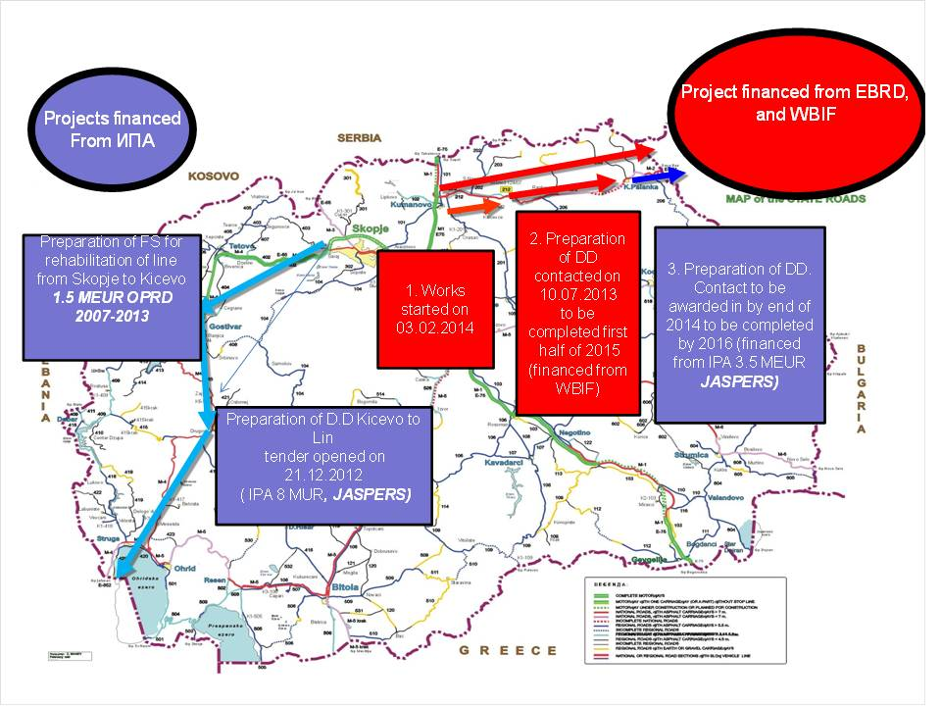
Illustration 8: Overview of investments on Rail Corridor VIII

On the Rail Corridor X as part of the SEETO Comprehensive rail network, ongoing and planned investments until 2017 is EUR 51 million. There are several projects which are under implementation such as:
- Reconstruction of the railway section between Bitola and Kremenica (16km). Works will start in second half of 2014 and finish in 2016. The project is financed from IPA I, OPRD 2007-2013 in amount of EUR 21 million.
- Preparation of project documentation and reconstruction, rehabilitation and upgrading of 10 Railway stations along the Corridor X and branch X-d. The project is financed from IPA I, OPRD 2007-2013 in the amount of EUR 3 million.
- Preparation of project documentation and procurement of equipment for GSMR and ETCS system installation on the Rail Corridor X. The project is financed from IPA I, OPRD 2007-2013 in the amount of EUR 6 million.
- Project for Rehabilitation and upgrading of the Railway Station – Skopje. The project is financed from IPA I, OPRD 2007-2013 in amount of EUR 2.6 million.
- EBRD provided EUR 17.6 million loan for rehabilitation of Rail Corridor X for track renewal along the railway line:
      - For section Tabanovce-Kumanovo (13km) contract was concluded in April 2012. Works on the Section Tabanovce-Kumanovo was completed in October 2013.
      - Works were completed on the section Miravci-Smokvica in June 2013.
      - For the section Nogaevci-Gradsko (28km) contract was concluded in July 2013 with duration of 365 days on amount of EUR 9,399,755. Works have commenced.
- Preparation of project documentation for reconstruction and rehabilitation of the Railway Section Veles-Bitola as part of branch X-d of Corridor X. The project is financed from IPA I, OPRD 2007-2013
- Preparation of project and design documentation for the section Veles – Dracevo was completed in 2013. The project is financed from IPA I, OPRD 2007-2013
- Preparation of project and design documentation for the section Kumanovo – Deljdarvoce to be completed in mid 2014. The project is financed from IPA I, OPRD 2007-2013

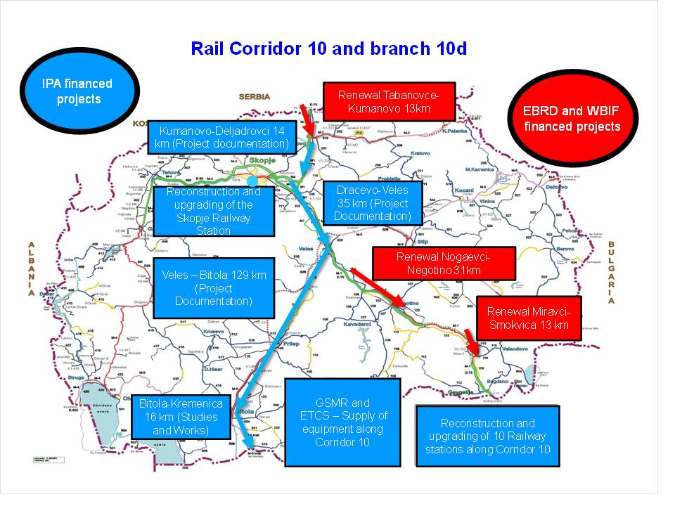
Illustration 9: Overview of investments on Rail Corridor X and Branch X d

Eligible Interventions under IPA II
- Construction of remaining railway links according to the EU technical standards
- Reconstruction, rehabilitation, upgrading and modernization of the existing railway sections with EU technical standards
- Improvement of rail safety
- Project preparation studies, as feasibility studies, cost-benefit analyses, EIA, design documentation and assistance with tendering and contracts (tender specification, evaluation, preparation of contracts, etc).
- Post-completion restoration activities, related to the measure

Selection Criteria: Operations to be financed under this activity will comply with the following selection criteria:
- Consistence with the national and regional policies
- Readiness of the project for implementation
- Adequate management capacity of the final beneficiary
- Sufficient financial condition of the beneficiary and available co-financing
- Professional competence of the management team

Beneficiaries: Ministry of Transport and Communications and "Public Enterprise Macedonian Railways-Infrastructure".

Result Monitoring indicators:

Indicator | Targets for period 2014-2020 | Source of verification
Length (km) of rail infrastructure reconstructed/rehabilitated/ constructed along SEETO Comprehensive Network with IPA II funds (baseline 0) | 23 km by 2020 | Eurostat/National Statistics Office/SEETO MAP/P.E. "Macedonian Railways Infrastructure "
Goods transported (thousands of tons) on annual basis by 2022 on C-VIII (baseline 0) | 500.000 tons of freight by 2020 | Eurostat, JSC "Macedonian Railways Transport"
Secured level crossings according to international standards and best practices (baseline – 81 level crossing) | 15 Level crossings secured by 2020 | Eurostat, PE "Macedonian Railways Infrastructure "

Priority action 2 – Road transport infrastructure

Aim: The purpose of the priority action is to improve road transport infrastructure for a better cohesion with the EU member states and regional neighbours, supported by varied investments in the transport infrastructure network of the country. For the programming period 2014-2020 the priority will be given to the road infrastructure along the SEETO comprehensive network (Corridors VIII, X and Branch X d)

EU legislation: REGULATION (EU) No 1315/2013 OF THE EUROPEAN PARLIAMENT AND OF THE COUNCIL of 11 December 2013 on Union guidelines for the development of the trans-European transport network and repealing Decision No 661/2010/EU

Specific objectives:
- To facilitate international and transit movements of people and goods with the EU and its regional neighbours by the modernisation and development of the Corridors and the regional core network
- To facilitate the effective movement of persons and goods that supports improved living standards and socio-economic environment in the regions through development of the national components of the Corridors
- To promote sustainable development especially through minimizing the adverse effects of transport on the environment and through improving transport safety
- To develop design studies, Environment Impact Assessments (EIA), project preparation studies as feasibility studies, cost-benefit analyses, design documentation and tender documentation of the projects where pre-feasibility studies already exist and are of the priority.

Rationale: The national territory is a crossing point of the two Trans National Axes (Corridors VIII and X) which is an opportunity for development of the national transport network in order to make the most of the geo-strategic advantage and thus to contribute to the functioning of the Common European Market by providing effective transport links and facilitating the transport of people and goods and access to the other countries and markets.

The regional core transport network is considered to be one of the most important policies for bringing long term peace, stability and economic prosperity to South-East Europe. Transport priority action will focus on the continuation of the Development of the South East Europe Core Regional Transport Network. This is in line with the political priorities set out in the European Partnership and the MoU signed in June 2004 between the representatives of the countries and administrative entities of the South East Europe and the Commission.

This priority action will contribute to better cohesion with the EU member states, by reducing travel times, supporting improved safety and quality of transport delivery both within the Country, to neighbouring countries and onward to other countries in the EU and the region. It will be achieved through activities aimed at development of motorways and road infrastructure. In this manner, improvements will also accrue in the quality, efficiency and speed of transport services, door-to-door leading to increases in freight and passenger traffic.

These regional priorities are matching also the needs identified in the economic and SWOT analysis of the transport sector.

Following the analysis the national and regional transport delivery suffered because of various weaknesses:

- Limited connections (road) with neighbouring states
- Unsatisfactory road condition in national network
- Unsatisfactory level of financing of road maintenance
- Cross border delays
- Inadequate funding available to fulfil all transport infrastructure project requirements

Description: The action comprises activities that will contribute to construction, reconstruction, rehabilitation and modernization of the road infrastructure (along the SEETO comprehensive network), with a special emphasis on the improvement of road safety. This also includes project preparation studies, feasibility studies, cost-benefit analyses, EIA, design documentation, tender documentation of the projects where pre-feasibility studies already exist.

Delivery: Delivery principles include support of investments in Transport infrastructure projects which are capital intensive. This approach will enable effective and efficient utilisation of the IPA assistance and continuation of the principle for investments set out in the period 2007-2013 of investment on SEETO Comprehensive Networks as part of the TEN_T network.

Targets and indicators The priority is targeted on the Road transport sector. The target commercial beneficiaries will include the importers and exporters of goods and products, including agricultural products, as well as those involved in internal trade movements and also those engaged in goods transit across South Eastern Europe. In addition, modern highways have high safety design standards that create benefits for all road users and contribute towards improvements in the safety standards and reductions of accidents, injuries and fatalities.

Upgrading and modernization of the Road Infrastructure along the SEETO comprehensive network (Corridors VIII, X and Branch X d)
Specific objectives:
- To construct, reconstruct, rehabilitate, upgrade and modernize the motorway sections on the Corridor VIII, X and Branch X d that are currently below standard
- To eliminate dangers and delays that currently occurs in this sub-standard stretch.
- To improve road safety, reduce accidents and ensure safer travelling environment
- To limit the harmful impact of road traffic on the environmental to an optimal level
- To increase the capacity of the connections with neighbouring countries along the Corridor VIII
- To develop design studies, Environment Impact Assessments (EIA), project preparation studies as feasibility studies, cost-benefit analyses, design documentation and tender documentation of the projects where pre-feasibility studies already exist.

Rationale: A well-developed and maintained road infrastructure provides the foundations for the country’s economic growth and sets the preconditions for development of the road transport.

The Corridor VIII spans over the South Eastern European area where transport infrastructure is traditionally weak. It is the energy and infrastructure axis connecting the Adriatic with the Black Sea. From an economic point of view, with the trans-European networks the European Commission aims at realising an enhanced access to EU countries, and thus develops an increased mobility of people and goods following the single market objectives and the principles of sustainable mobility. Corridor VIII develops a system of transportation that clearly would foster improved trade within the region. It would bring economic development benefits to the sub-regions and municipalities along its route and better connect inland localities to ports on both the Adriatic and Black Seas, allowing better access to raw materials and markets. In view of future planning for the extension of the TEN-T network it is of common interest of all the countries of the region to consider Corridor VIII the Motorway of the Sea connecting Varna/Burgas, Sofia, Skopje, Tirana, Durres to Bari/Brindizi in Italy (the Black Sea with the Adriatic Sea).

Corridor X is the most important element of the core transport network, linking from Greece to Austria. Present average annual daily traffic of 15,000 is set to increase at 6% per annum to over 20,000 and to 40,000 by 2020. The E-75 is mostly four lane tolled motorway. A high proportion (25%) of it is regional or international. Within the national territory, the relevant part of the Corridor X is in concordance with National road M-1 (international mark E-75), which crosses the territory in direction North-South. Within the country, the traffic volume on the Corridor X averages around 5.000 vehicles per day. For the period 2008-2012 was foreseen an increase in traffic volume of 5% per annum, reaching approximately 6.300 vehicles per day for year 2012 and up to 10.000 vehicles per day by 2020-2025.

There are number of projects at a stage of preparation of comprehensive project documentation in order to be able to apply for financing for the physical works from IPA II or other IFIs. Therefore the support of the activity is focused on specific projects, where preparatory activities are ongoing and will be completed before the application for financing for the physical works is submitted.

This activity will also include preparation of feasibility studies, cost benefit analyses, environmental impact assessments, design documentation etc for other projects within the field of the rail infrastructure.

Description: Concerning road infrastructure along Corridor X, as part of the SEETO Comprehensive road network,, at present there are completed investments for period 1990 - 2013 in amount of EUR 96 million. For the coming period with the planned and ongoing investments to be completed by 2019 the amount is going to increase to EUR 337 million. Road Corridor X is 83% to level of motorway standards and 17 % in the phase of construction (section Demir Kapija – Smokvica). The scope of investments on the Corridor X and Xd so far included project such as:
- Section Negotino – Demir Kapija was constructed in three phases. The construction started in September 2000 and finished in October 2005, with total length of 15.74 km and budget of EUR 24.7 million. The first two phases were financed through PHARE – Programme and the third phase was financed through CARDS – Program.
- Section Smokvica – Gevgelija was financed through EBRD and it was completed in January 2006 with length of 11.22 km.
- Section Gevgelija – Bogorodica (Border with Greece) was finished in 2000. It was financed by European Commission and PHARE – Programme with length of 4.6 km and a budget of EUR 6.2 million.
- Section Tabanovce – Kumanovo financed from the World Bank was completed in 2011.
- First two phases of rehabilitation of bridges on Road Corridor X financed from NATO in an amount of EUR 26 million were completed in the period 2006-2008. Ongoing is third phase of rehabilitation of bridges on Road Corridor X in amount of EUR 8.6 million financed form NATO (first two phase in an amount of EUR 26 million were completed in the period 2006-2008);
- Competed rehabilitation of section from Katlanovo to Veles in 2013 in amount of EUR 7 million financed from the state budget; works for rehabilitation of section from Veles to Katlanovo financed from IPA I in an amount of EUR 8 million will start in mid-2014 and should be completed in mid-2015.
- Road section from Demir Kapija to Smokvica is under construction with a cost of EUR 219 million, financed from IPA I, EBDR and EIB.
- Works for reconstruction and rehabilitation of section from Smokvica to Gevgelija financed from IPA I in an amount of EUR 7 million are planned to start in first half of 2015 and should be completed in 2016.
- Works for Rehabilitation of section from Kumanovo to Miladinovce financed from IPA I are planned to start in 2016 and should be completed in 2017.
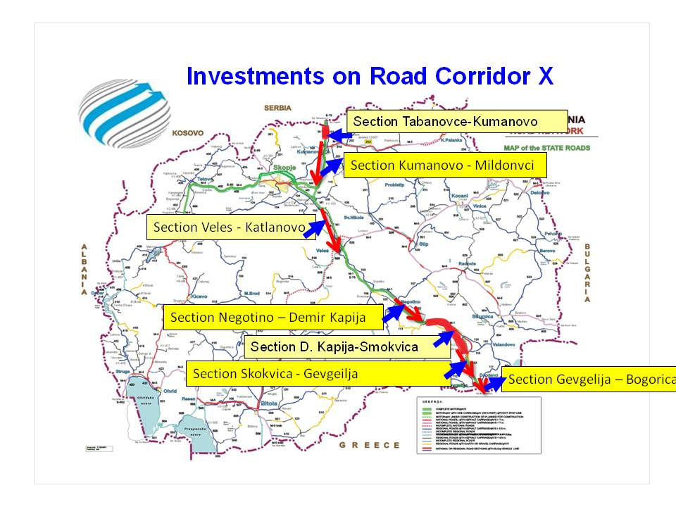
Illustration 10: Overview of investments on the Road Corridor X

Road Corridor X-d as part of the SEETO Comprehensive road network,is comprised of the following sections:
- Section from Gradsko to Drenovo is planned to be financed under IPA II, 2014-2020 in an amount of EUR 40 million.
- For section from Drenovo to Raec brigde is planned to be implemented from loan form EBRD. Time frame for 2015 to 2017 in an amount of EUR 40 million.
- Section from Raec Bridge to Kamenolom adding a third lane was implemented in 2006 financed from the state budget
- Section from Kamenolom to Belovodica is planned to be financed from the state budget for extending the road with a third lane
- Section from Belovodica to Leniska reka, extending the road with a third lane was implemented in 2006 financed from the state budget
- Section from Leniska reka to Prilep extending the road with a third lane is planned to be financed from the state budget
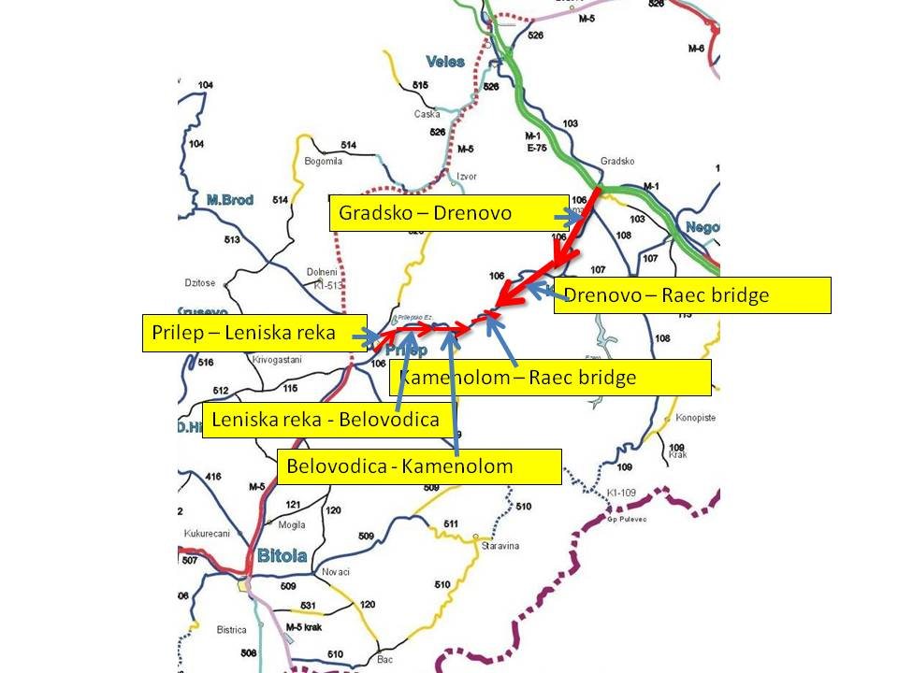
Illustration 11: Overview of investments on the Road Corridor X, Branch X-d

On the Road Corridor VIII as part of the SEETO Comprehensive road network, there are completed investments in the period of 2000-2013 in an amount of EUR 242 million. In the forthcoming period there are ongoing and planned investments for 2014-2019 is EUR 440 million

In Republic of Macedonia, road Corridor VIII extends from the East to the West part of the national territory and in total length of around 304 km. From the aspect of the road infrastructure along the Corridor, approximately 37% of the total length is on a level of standard modern motorway, among which are the following sections: Skopje-Tetovo-Gostivar, Skopje by-pass and Tetovo as well as Kumanovo-Skopje.

In November 2009, the Government of the Republic of Macedonia published the Public Announcement for submission of requests for participation in the procedure for awarding concession for activities for construction, reconstruction, maintenance, pay-toll and usage of part of the state roads in in the country for Package 1 and Package 2 for Corridor VIII, which was not successful due to the fact that there were no bids from the 5 prequalified consortia and the procedure was sTSOPped in October 2011.

Road Corridor VIII passes through Struga, Gostivar, Tetovo, Skopje and Kriva Palanka and it can be divided in following main sections:
- Ohrid – Kicevo with length of 57 km will be constructed to motorway standards until 2018. The construction works began in March 2014 and the funds in an amount of EUR 374 million are secured from the China EXIM Bank.
- For the Kicevo – Gostivar section, at the moment IFC is looking into the possibility to finance the construction works though PPP.
- Section Gostivar - Tetovo was completed to motorway standards in 1995 and construction works for section Tetovo – Skopje was completed to motorway standards in 2002 with construction works in an amount of EUR 57 million
- Skopje by-pass (26.7 km) was completed to motorway standards in 2009. The construction works were in an amount of EUR 150 million
- Section Skopje – Kumanovo (33 km) is completed to motorway standards.
- Section Kumanovo – border with R. Bulgaria from point Rankovce to Kriva Palanka in length of 22 km are planned to be upgraded until 2018 with funds from the World Bank in an amount of EUR 70 million.
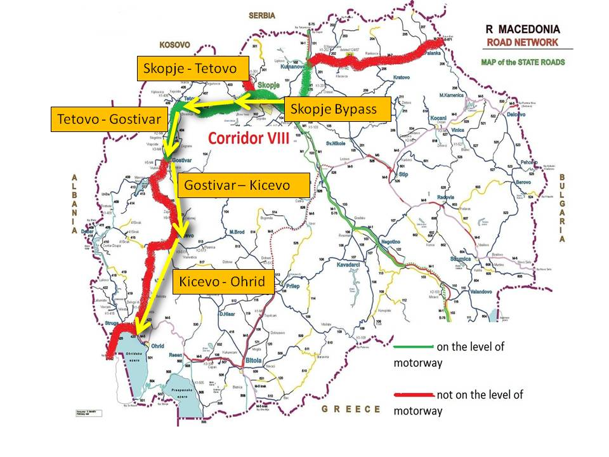
Illustration 12: Overview of investments on the Road Corridor VIII

Eligible Interventions under IPA II

- Construction, reconstruction, rehabilitation, upgrading, modernization and Supervision of works of the motorway sections on the Corridors VIII, X and Branch X d according to the EU technical standards The intervention include motorway construction and associated support structures, related procurement contracts, assistance with tendering and contracts (tender specifications, evaluation, preparation of contracts, etc.)
- Improvement of road safety
- Project preparation studies, as feasibility studies, cost-benefit analyses, environment impact assessments, design documentation, and assistance with tendering and contracts (tender specification, evaluation, preparation of contracts, etc) with the view to reconstruction, rehabilitation, upgrading and modernization of the existing motorways with EU technical standards
- Post-completion restoration activities, related to the measure

Selection Criteria: Operations to be financed under this activity will comply with the following selection criteria:
- Consistence with the national and regional policies
- Readiness of the project for implementation
- Greater positive impact on population and least impact on nature
- Adequate management capacity of final beneficiary
- Sufficient financial condition of the beneficiary and available co-financing

Final Beneficiaries: Ministry of Transport of Transport and Communications and Public Enterprise for State Roads-PESR will be the final beneficiaries.

Result Monitoring Indicators:

Indicator | Targets for period 2014-2020 | Source of verification
Length (km) of roads reconstructed/rehabilitated/constructed along SEETO Comprehensive Network (baseline 16 km) | 98 km by 2020 | Eurostat/National Statistic Office/P.E State Roads and SEETO MAP
Increased road safety measures/ decreased number of black spots along the SEETO comprehensive network | Reduction by 30% of the road safety fatalities, 3 to 6 eliminated black spots, by 2020 | National Statistic Office/Ministry of Interior

Priority action 3 – Horizontal sector assistance

Aim: To provide horizontal assistance in the Transport sector to i.a. support the implementation of sector governance, sector wide reforms, specific transport activities not covered by Priority Actions 1 and 2 and to support the effective management and implementation of the Transport Sector Operational Programme 2014-2020.

Specific Objectives:
- To achieve the administration of IPA II assistance implementation within the SOPT 2014-2020 being carried out in due course.
- Strengthening and enhancing the administrative capacity of the administrative structures.
- To support the preparation and implementation of activities in the area of green urban transport.
- To support the Government structures in the improvement of sector governance and the implementation of transport sector reforms.
- To support the preparation of strategic and operational documents (i.e. future transport operational programmes, technical project documentation, etc.).
- To make the public well informed and aware of the support from IPA and in particular of SOPT.

Rationale
The management and implementation of sector reforms requires particular horizontal sector assistance measures in order to support sector governance, the capacity building of sector stakeholders and the administrative and legal structures for the implementation of sector reforms.

Actions 1 and 2 cover only a limited number of activities as defined in the Transport sector strategic documents. Priority Action 3 will therefore be able to cover a number of horizontal transport issues not addressed by those first two Priority Actions. A particular focus will be put on the development and implementation of activities in the area of green urban transport. In addition Priority Action 3 will address sector shortcomings and provide support to improve sector governance, strengthen the capacities of key sector stakeholders and support the approximation of the legal framework and the appropriate administrative capacities with the EU acquis. In addition this Priority Action will also support the concrete implementation of the SOP, by providing capacity building for the relevant actors, support in the preparation of technical documentation, supporting the development of future EU support measures, etc.

Description:
The action comprises activities that will contribute to proper implementation of Transport sector reforms and will focus i.a. on the following elements:
- Strengthen the capacities of the national stakeholders for establishing and further developing a proper sector approach framework
- To finance preparatory, management, monitoring, evaluation information and control activities in order to reinforce the administrative capacity for implementing the Sector transport reforms
- Information evaluation, audit and control activities
- Conducting visibility and communication activities linked e.g. to the IPA assistance but also to wider transport areas, such as road safety, etc.;
- Support in the area of green and urban transport
- Horizontal support to transport inspectorates and other bodies on central and local level.
- Support to gradual move towards sector based approach
- Support for preparation of project documentation for multi modal transport nodes
Identification of potential future projects eligible for financing and their preliminary assessment give the basis to compile the project pipeline including only the selected projects meeting the objectives of the programme.
- Use of external expertise necessary for the development of high quality strategic transport and programme documents/plans/manuals; technical studies and databases; conducting independent analyses and assessments and other relevant activities in relation to the preparation, monitoring, management, control, evaluation and audit of the SOPT;

Delivery:
The horizontal sector assistance shall be implemented through service, grants and Twining contracts.. The implementation of the activity requires, among others:
- Training of staff on project management and IPA II implementation rules,
- Evaluations, expert reports, statistics and studies
- Measures to disseminate information, networking, raise awareness, promote cooperation and exchange experiences;
- Improvements in evaluation methods and the exchange of information on practices in this field.
- Ensuring the implementation of motivational scheme for employees of the beneficiaries of the programme for regular and overtime work on management, ensuring financial resources for remuneration, overtime work and social contributions for employees - in accordance with the established national rules;

Targets and indicators:
Action 3 is targeted for key sector stakeholders and for the TSOP 2014-2020 management bodies responsible for identification, design, implementation and monitoring in accordance with approved procedures.
Wider public is targeted also through the measures that focus on increase of public awareness about EU support and relevant sector reforms.

Eligible interventions under IPA II:
- Technical assistance to improve sector governance.
- Capacity building of key sector stakeholders.
- Measures to support the implementation of green urban transport activities.
- Organization of yearly sector review studies and meetings.
- TA for the approximation of the legal framework with the EU acquis.
- Project preparation studies, as feasibility studies, cost-benefit analyses, environment impact assessments, design documentation, and assistance with tendering and contracts along SEETO Comprehensive Network.
- Drawing up programme documents for the next programming period and revision of ongoing programme.
- Preparation, organization and carrying out trainings of OS staff (focus to be put on workshops, seminars, exchange of good practices and experience with other EU member States, including financing for participation in relevant international events).
- Monitoring to support SOPT implementation.
- Actions related to the Sector monitoring committee as referred in the Implementation.
- Implementation of communication activities, organisation of campaigns to make the public well informed and aware of the support from IPA and relevant transport reforms and policies.
- Support evaluation, audit and control activitiesof the SOPT, including technical audit assistance for major projects.
- Providing support and guidance though the JASPERS instrument (Joint Assistance to Support Projects in European Regions).
- Development of project documentation for multi modal transport nodes.
- Provision of technical assistance, including surveys, analyses and evaluations (ex-ante, on-going and ex-post), as well as advice from national and international experts on various aspects of the management and implementation of activities under the Structural and Cohesion Funds, including preparation of tender specifications.
- Drawing up sector studies, strategies, master plans, investment studies and other documents at national and regional level necessary for planning interventions.
- Provision of technical assistance related to transfer of practical experience in the area of identification, assessment and selection of eligible projects and projects preparation and implementation (coaching /on the job support).
- Project preparation studies, as feasibility studies, cost-benefit analyses, environment impact assessments, design documentation, and assistance with tendering and contracts for urban and green transport.

Final Beneficiaries:
- Operating structure, MoTC, Specific bodies and end recipients

Result Monitoring indicators:
Indicator | Targets for period 2014-2010 | Source of verification
Total number implemented projects in the area of urban and green transport | Programme monitoring | Programme monitoring
Total number of prepared project documentation for multimodal transport | Programme monitoring | Programme monitoring
Number of communication campaigns carried out for improved safety in transport sector | Managing authority  Programme monitoring | Managing authority  Programme monitoring
Total number of technical audits made for Major Projects | Programme monitoring | Programme monitoring
Production of relevant sector statistics and establishment of a comprehensive data collection system | Programme monitoring | SSO, MoTC

Methodology for selection of projects
Multi Criteria Analyses-MCA

The selection of the projects for each priority action would be based on Multi Criteria Analyses which takes into account three basic sets of criteria, as previously agreed with the Commission:
- level of compliance (shortly indicated as “compliance” below) with EU and national policies and maturity,
- impact of the project and
- maturity of the project (shortly indicated as “impact” and “maturity” below).
Criteria and parameters to be considered in the analysis are listed below. For each of the 3 basic criteria (compliance, impact and maturity), different indicators are defined according to the overall objective of the project, as shown in the scheme below.

CRITERIA: Compliance, Impact, Maturity
INDICATORS:
The following indicators would be considered:
- Compliance indicators:
  - Compliance with EU policies, legislation and directives
  - Compliance with international conventions
  - Compliance with national strategies and legislation
  - Compliance with regional and geographical balance
- Impact indicators:
  - Estimated social impact
  - Estimated environmental impact
- Maturity indicators:
  - Technical constraints
  - Overall maturity of the project
  - Estimated time needed for maturity
  - Estimated cost for each project
  - Estimated duration of each project

PARAMETERS: The above-mentioned indicators require quantifiable terms, or, at least, a qualitative assessment based on an expertise. The following quantitative or qualitative parameters are to be taken into consideration:
- Compliance indicators: for any indicator, a qualitative assessment (not in compliance, partially in compliance, fully in compliance)
- Impact indicators:
  - Estimated social impact: draft assessment based on a qualitative scale (low impact, medium impact, high impact, etc.)
  - Estimated environmental impact: draft assessment based on a qualitative scale (low impact, medium impact, high impact, etc.)
- Maturity indicators:
  - Technical constraints: draft assessment based on a qualitative scale (low impact, medium impact, high impact, etc.)
  - Maturity of the project: draft qualitative assessment, as above (low, medium, high maturity)
  - Estimated time needed for maturity: draft quantitative assessment, in terms of remaining months
  - Estimated cost for each project: estimated cost (from available feasibility studies when available)
  - Estimated duration of each project: draft quantitative assessment of project lifetime.

RANGE of VALUES: Each PARAMETER is characterized by the amplitude of value ranges. But values are actually expressed in different units and most of them may also be simply qualitative, as above specified.

This is the reason why the parameters are represented by “utility values” that are given to each value unit of the range (or considering the maximum – minimum extent of each value). Consequently every criteria parameter i may be expressed, for a given project k with an “utility value” U_{i,k} that is conventionally between 0 and 1 :
0 < U_{i,k} < 1

WEIGHTS: Weights represent the importance that national and local communities give to the particular indicator, and are expressed by weight factors A_{i} which represents the importance that the decision maker assign to the criteria in the overall assessment.

SCORE: The individual score is the result of the product between points and weights attributed to the indicator and the total scores represent the final judgment for each alternative. At the end, to any k project an utility function value U_{k} may be associated, being:
The U_{k} value was adopted in order to set-up a ranking among the projects.

The MCA produces a sort of “classification” among projects, thus identifying priorities and critical situations. A list of required actions for each project is produced in parallel with the results of MCA in order to identify tangible initiatives to be carried out in order to bring each project at an acceptable degree of maturity. Such list is the base for the final “Action plans” development.
The following points explain with some more details the above activities
Preliminary identification of projects
Analysis of each project (maturity and coherence with local and EU policies, etc.)
MCA Analysis
Identification of specific needs for each project
Ranking and scores
Technical documentation
Timeline
Indicative budget
Possible sources of funding
Responsibilities
Action Plan

Preliminary identification of projects

The preliminary identification of projects consists of a quick screening of projects carried out in cooperation between MoTC and other stakeholders aimed to identify project that can be actually included in the list of the possible IPA-supported projects. This activity consists of an identification of those initiatives which are yet included into the IPA strategic documents or that can be further introduced being in coherence with IPA’s requirements. Proposals not in coherence with these requirements are not considered at all in the further steps of the project identification.

Indicative List of major projects

Based on the MCA the following projects are foreseen as Major projects within the TSOP 2014-2020:
1. Construction of railway line from Kriva Palanka to border with Republic of Bulgaria.
2. Construction of road section from Gradsko to Drenovo as part of the road Corridor X-d
Indicative list of major projects is annexed to the document.

IPA II Financial allocations per year

Financial tables 2014-2020 are based on 85% IPA contribution and 15% National co-financing. They reflect the major projects identified in the TSOP.

Year 2014 | Total  Public  Expenditure  (€)  (1)=(2)+(3) | EU  Contribution  (IPA)  (€) (2) | National Public  Contribution  (€)  (3)* | IPA co-  Financing  Rate  (%)  (4)=(2)/(1)
Priority Action 1 Rail transport infrastructure | 0.00 | 0.00 | 0.00 | 85%
Priority Action 2 Road transport infrastructure | 4,705,882.35 | 4,000,000.00 | 705,882.35 | 85%
Priority Action 3 Complementary assistance | 0.00 | 0.00 | 0.00 | 85%
Total Year 2014 | 4,705,882.35 | 4,000,000.00 | 705,882.35 | 85%

Year 2015 | Total  Public  Expenditure  (€)  (1)=(2)+(3) | EU  Contribution  (IPA)  (€) (2) | National Public  Contribution  (€)  (3)* | IPA co-  Financing  Rate  (%)  (4)=(2)/(1)
Priority Action 1 Rail transport infrastructure | 0.00 | 0.00 | 0.00 | 85%
Priority Action 2 Road transport infrastructure | 16,556,000.00 | 14,072,600.00 | 2,483,400.00 | 85%
Priority Action 3 Complementary assistance | 716,992.80 | 609,443.88 | 107,548.92 | 85%
Total Year 2015 | 17,272,992.80 | 14,682,043.88 | 2,590,948.92 | 85%

Year 2016 | Total  Public  Expenditure  (€)  (1)=(2)+(3) | EU  Contribution  (IPA)  (€) (2) | National Public  Contribution  (€)  (3)* | IPA co-  Financing  Rate  (%)  (4)=(2)/(1)
Priority Action 1 Rail transport infrastructure | 0.00 | 0.00 | 0.00 | 85%
Priority Action 2 Road transport infrastructure | 20,385,176.47 | 17,327,400.00 | 3,057,776.47 | 85%
Priority Action 3 Complementary assistance | 1,055,489.20 | 897,165.82 | 158,323.38 | 85%
Total Year 2016 | 21,440,665.67 | 18,224,565.82 | 3,216,099.85 | 85%

Year 2017 | Total  Public  Expenditure  (€)  (1)=(2)+(3) | EU  Contribution  (IPA)  (€) (2) | National Public  Contribution  (€)  (3)* | IPA co-  Financing  Rate  (%)  (4)=(2)/(1)
Priority Action 1 Rail transport infrastructure | 900,000.00 | 765,000.00 | 135,000.00 | 85%
Priority Action 2 Road transport infrastructure | 12,283,058.59 | 10,440,599.80 | 1,842,458.79 | 85%
Priority Action 3 Complementary assistance | 20,000.00 | 17,000.00 | 3,000.00 | 85%
Total Year 2017 | 13,653,000.00 | 11,222,599.80 | 1,980,458.79 | 85%

Year 2018 | Total  Public  Expenditure  (€)  (1)=(2)+(3) | EU  Contribution  (IPA)  (€) (2) | National Public  Contribution  (€)  (3)* | IPA co-  Financing  Rate  (%)  (4)=(2)/(1)
Priority Action 1 Rail transport infrastructure | 33,000,000.00 | 28,050,000.00 | 4,950,000.00 | 85%
Priority Action 2 Road transport infrastructure | 639,000.00 | 543,150.00 | 95,850.00 | 85%
Priority Action 3 Complementary assistance | 0 | 0 | 0 | 85%
Total Year 2018 | 33,639,000.00 | 28,593,150.00 | 5,045,850.00 | 85%

Year 2019 | Total  Public  Expenditure  (€)  (1)=(2)+(3) | EU  Contribution  (IPA)  (€) (2) | National Public  Contribution  (€)  (3)* | IPA co-  Financing  Rate  (%)  (4)=(2)/(1)
Priority Action 1 Rail transport infrastructure | 37,588,236.00 | 31,950,000.60 | 5,638,235.40 | 85%
Priority Action 2 Road transport infrastructure | 30,000.00 | 25,500.00 | 4,500.00 | 85%
Priority Action 3 Complementary assistance | 100,000.00 | 85,000.00 | 15,000.00 | 85%
Total Year 2019 | 37,718,236.00 | 32,060,500.60 | 5,657,735.40 | 85%

Year 2020 | Total  Public  Expenditure  (€)  (1)=(2)+(3) | EU  Contribution  (IPA)  (€) (2) | National Public  Contribution  (€)  (3)* | IPA co-  Financing  Rate  (%)  (4)=(2)/(1)
Priority Action 1 Rail transport infrastructure | 0 | 0 | 0 | 0%
Priority Action 2 Road transport infrastructure | 5,000.00 | 4,250.00 | 750.00 | 85%
Priority Action 3 Complementary assistance | 150,000.00 | 127,500.00 | 22,500.00 | 85%
Total Year 2020 | 155,000.00 | 131,750.00 | 23,250.00 | 85%

TOTAL Years 2014- 2016 | Total  Public  Expenditure  (€)  (1)=(2)+(3) | EU  Contribution  (IPA)  (€) (2) | National Public  Contribution  (€)  (3)* | IPA co-  Financing  Rate  (%)  (4)=(2)/(1)
Priority Action 1 Rail transport infrastructure | 0.00 | 0.00 | 0.00 | 85%
Priority Action 2 Road transport infrastructure | 41,647,058.82 | 35,400,000.00 | 6,247,058.82 | 85%
Priority Action 3 Complementary assistance | 1,772,482.00 | 1,506,609.70 | 265,872.30 | 85%
Total 2014-2016 | 43,419,540.82 | 36,906,609.70 | 6,512,931.12 | 85%

TOTAL Years 2017-2020 | Total  Public  Expenditure  (€)  (1)=(2)+(3) | EU  Contribution  (IPA)  (€) (2) | National Public  Contribution  (€)  (3)* | IPA co-  Financing  Rate  (%)  (4)=(2)/(1)
Priority Action 1 Rail transport infrastructure | 71,488,236.00 | 60,765,000.60 | 10,723,235.40 | 85.00%
Priority Action 2 Road transport infrastructure | 12,957,058.59 | 11,013,499.80 | 1,943,558.79 | 85.00%
Priority Action 3 Complementary assistance | 270,000.00 | 229,500.00 | 40,500.00 | 85.00%
Total 2017-2020 | 84,715,294.59 | 72,008,000.40 | 12,707,294.19 | 85.00%

TOTAL Years 2014-2020 | Total  Public  Expenditure  (€)  (1)=(2)+(3) | EU  Contribution  (IPA)  (€) (2) | National Public  Contribution  (€)  (3)* | IPA co-  Financing  Rate  (%)  (4)=(2)/(1)
Priority Action 1 Rail transport infrastructure | 71,488,236.00 | 60,765,000.60 | 10,723,235.40 | 85.00%
Priority Action 2 Road transport infrastructure | 54,604,117.41 | 46,413,499.80 | 8,190,617.61 | 85.00%
Priority Action 3 Complementary assistance | 2,042,482.00 | 1,736,109.70 | 306,372.30 | 85.00%
Total 2014-2020 | 128,134,835.41 | 108,914,610.10 | 19,220,225.31 | 85.00%

Overview of the consultation process

The consultation processes ensure that the preparation of the Sectoral Operational Program on Transport at different stages of programming process is discussed and consulted with stakeholders relevant to the sector, beneficiaries, public authorities and other economic and social partners.

The first draft of the SOPT was prepared by the Ministry of Transport and communications with inter-service consultation. After this process the draft SOPT was sent to intra-service consultations within the relevant Ministries and other public authorities and was sent to the Government. After having all positive opinions the information note was adopted by the Government on 30.04.2014. After this the SOPT was sent to the Delegation of the EU on 05.05.2014.

Comments from the DEU were provided on 15.05.2014 and afterwards a meeting with the representatives of the EC, DEU and national authorities was held on 22.05.2014.

The SOPT was revised and sent to the DEU on 02.06.2014 and meeting for consultation was held on 03.06.2014 in the premises of the DEU where representatives from the SEA and Ministry of transport participated. The revised version of the OP was sent to DEU and EC in june 2014 and comments were provided from the EC on 01.08.2014. Technical meeting was held on 27.08.2014 in the premises of the DEU. The revised version was sent to the DEU and EC by the NIPAC on 01.09.2014.

On a programme level consultations with governmental institution, basic stakeholders, NGOs, Municipalities and all relevant institutions took place while drafting the OPT 2014-2020.

On action level public consultations according to relevant national legislation takes place for every major project during the preparatory phase and all concerned stakeholders, municipalities and NGO’s were consulted on the Operational Programme and were duly informed for the major projects. After the consultations are held the opinions and remarks are taken on board and incorporated in the project preparation phase.

For instance, such consultations were done for the previous major project for construction of the new motorway section on Corridor X Demir Kapija – Smokvica as well as for the major project for renewal with reconstruction of the railway section Bitola-Kremenica as part of the branch Xd of the Corridor X.

JASPERS (Joint Assistance to Support Projects in European Regions) provides guidance and advice during project preparation, to help improve the quality of the major projects to be submitted for grant financing under IPA Assistance. JASPERS instrument is an important quality management tool for infrastructure projects implementation since it provides technical expertise for any stage of the project cycle from the early stages of project conception through to the final application for EU funding. In Republic of Macedonia, JASPERS supported implementation of several projects related to road transport infrastructure (Motorway section Veles - Katlanovo rehabilitation, Reconstruction and upgrading of the motorway section Smokvica-Gevgelija, as part of Corridor X) and railway transport infrastructure (new Rail Section Kriva Palanka - Bulgarian Border, New Rail Section Kicevo - Albanian Border and Rehabilitation of the rail section Bitola - Kremenica). Based on the valuable input form JASPERS in the project preparation in 2013 and 2014 it is expected to extend the cooperation in the period 2014-2020, on the issues such as but not only limited to project review and recommendations, horizontal tasks, strategic support, capacity building and implementation support.

Implementation, monitoring and evaluation arrangements

Description of relevant structures and authorities for the management and control of the programme

Bodies and authorities
The Government of the beneficiary country will adopt its own legal act/s, which will designate specific bodies for IPA management and implementation roles.
Under the management and control provisions of this Regulation, the following individuals / bodies will be designated / established
- National IPA Coordinator
- National Authorising Officer
- National Fund
- Audit Authority
- Operating Structure

National IPA Coordinator (NIPAC) is a high-ranking official in the state administration, who shall ensure the overall coordination of assistance under the IPA Regulation. NIPAC shall, in particular:
- ensure partnership between the Commission and the Republic of Macedonia, and a close link between the general accession process and the use of assistance under the IPA Regulation;
- bear overall responsibility for:
  - the coherence and coordination of the programmes provided under this Regulation,
  - the annual programming for the transition assistance and institution building component at national level,
  - the coordination of the participation of the beneficiary country in the relevant cross-border programmes, both with Member States and with other beneficiary countries, as well as in the transnational, interregional or sea basins programmes under other Community instruments. The national IPA coordinator may delegate the tasks relating to this coordination to a cross-border cooperation coordinator,
- draw up and, after examination by the IPA monitoring committee, submit the IPA annual and final reports on implementation to the Commission with a copy to the national authorising officer.

National Authorising Officer (NAO) shall be a high-ranking official in the state administration of the Republic of Macedonia. NAO shall:
- as the head of the National Fund, bear overall responsibility for the financial management of EU funds in the beneficiary country; he shall be responsible for the legality and regularity of the underlying transactions;
- be responsible for the effective functioning of management and control systems under the IPA Regulation.

For the purposes of point (1), the National Authorising Officer shall in particular fulfill the following tasks:
- provide assurance about the regularity and legality of underlying transactions;
- draw up and submit to the Commission certified statements of expenditure and payment applications; the National Authorising Officer shall bear overall responsibility for the accuracy of the payment application and for the transfer of funds to the Operating Structures and/or final beneficiaries;
- verify the existence and correctness of the co-financing elements;
- ensure the identification and immediate communication of any irregularity;
- make the financial adjustments required in connection with irregularities detected,
- be the contact point for financial information sent between the Commission and Republic of Macedonia.

For the purposes of point (2), the National Authorising Officer shall in particular fulfill the following tasks:
- be responsible for issuing, monitoring and suspending or withdrawing the accreditation of the Operating Structures;
- ensure the existence and effective functioning of systems of management of assistance under the IPA II IR
- ensure that the system of internal control concerning the management of funds is effective and efficient;
- report on the management and control systems;
- ensure that a proper reporting and information system is functioning;
- follow-up the findings of audit reports from the audit authority,
- immediately notify the Commission, with a copy of the notification to the competent accrediting officer, of any significant change concerning the management and control systems.

Pursuant to the responsibilities laid down in points (1) and (2), the National Authorising Officer shall draw up an annual statement of assurance.

The National Fund (NF) shall be a body located in the Ministry of Finance in the Treasury Department, the department which has central budgetary competence. The National Fund shall act as a central treasury and be in charge of tasks of financial management of assistance under the IPA Regulation, under the responsibility of the National Authorising Officer. It shall in particular be in charge of organising the bank accounts, requesting funds from the Commission, authorising the transfer of funds received from the Commission to the operating structures or to the final beneficiaries, and the financial reporting to the Commission. Head of National Fund is a government official responsible for the proper performance of the functions of the National Fund, being directly responsible to the NAO.

An Audit Authority, functionally independent from all actors in the management and control systems and complying with internationally accepted audit standards, was established in the State Audit Office. The Audit Authority shall be responsible for verifying the effective and sound functioning of the management and control systems. The Audit Authority shall be responsible for verifying the effective and sound functioning of the management and control systems. The Audit Authority, under the responsibility of its head, shall in particular:
- during the course of each year, establish and fulfill an annual audit work plan which encompasses audits aimed at verifying:
  - the effective functioning of the management and control systems,
  - the reliability of accounting information provided to the Commission.
The audit work shall include audits of an appropriate sample of operations or transactions, and an examination of procedures.
The annual audit work plan shall be submitted to the national authorising officer and the Commission before the start of the year in question.
- submit the following:
  - an annual audit activity report following the model to be found in the framework agreement, setting out the resources used by the Audit Authority, and a summary of any weaknesses found in the management and control systems or in transaction findings from the audits carried out in accordance with the annual audit work plan during the previous 12 month period. The annual audit activity report shall be addressed to the Commission, the national authorising officer, and the competent accrediting officer, by 31 December each year.
  - an annual opinion following the model set out in the framework agreement as to whether the management and control systems functions effectively and con-forms to the requirements of this Regulation and/or any other agreements between the Commission and the Republic of Macedonia. This opinion shall be addressed to the Commission, the national authorising officer, and the competent accrediting officer. It shall cover the same period and have the same deadline as the annual audit activity report,
  - an opinion on any final statement of expenditure submitted to the Commission by the national authorising officer, for the closure of any programme or of any part thereof. Where appropriate, the final statement of expenditure may include payment applications in the form of accounts submitted annually. The opinion on any final statement of expenditure shall follow the model provided in annex to the framework agreement. It shall address the validity of the final payment application and the accuracy of the financial information, and, where appropriate, be supported by a final audit activity report. It shall be sent to the Commission and to the competent accrediting officer, at the same time as the relevant final statement of expenditure submitted by the national authorising officer, or at least within three months of the submission of that final statement of expenditure.
Further specific requirements for the annual audit work plan and/or the reports and opinions mentioned in paragraph (b) may be set out in the sectoral or financing agreements.
With regard to the methodology for the audit work, reports and audit opinions required by this IPA IR, the Audit Authority shall comply with international standards on auditing, in particular as regards the areas of risk assessment, audit materiality and sampling. That methodology may be complemented by any further guidance and definitions from the Commission, notably in relation to an appropriate general approach to sampling, confidence levels and materiality.

Operating Structure for the Sector Operational Programme on Transport 2014-2020
Under the Decentralized Implementation System in the Republic of Macedonia, the Central Financing and Contracting Department as part of the Operating Structure for the Transport Operational Programme 2014-2020 in charge of tendering, contracting and payments will perform the role of a Contracting Authority, being responsible for the financial and administrative side of the procurement of services, supplies, works, grants and twinning of all programmes/projects and timely implementation and execution of EU funded projects/programmes. In this process the European Commission (EC) will exercise systematic ex-ante control over the processes in the Operating Structure. The Operating Structure shall be responsible for managing and implementing the programme or programmes concerned in accordance with the principle of sound financial management. For those purposes, it shall carry out a number of functions that include:
- drafting the annual or multi-annual programmes;
- monitoring programme implementation and guiding the work of the sectoral monitoring committee, notably by providing the documents necessary for monitoring the quality of implementation of the programmes;
- drawing up the sectoral annual and final implementation reports and after their examination by the sectoral monitoring committee, submitting them to the Commission, to the national IPA coordinator and to the national authorising officer;
- ensuring that operations are selected for funding and approved in accordance with the criteria and mechanisms applicable to the programmes, and that they comply with the relevant Community and national rules;
- setting up procedures to ensure the retention of all documents required to ensure an adequate audit trail;
- arranging for tendering procedures, grant award procedures, the ensuing contracting, and making payments to, and recovery from, the final beneficiary;
- ensuring that all bodies involved in the implementation of operations maintain a separate accounting system or a separate accounting codification;
- ensuring that the national fund and the national authorising officer receive all necessary information on the procedures and verifications carried out in relation to expenditure;
- setting up, maintaining and updating the reporting and information system;
- carrying out verifications to ensure that the expenditure declared has actually been incurred in accordance with applicable rules, the products or services have been delivered in accordance with the approval decision, and the payment requests by the final beneficiary are correct. These verifications shall cover administrative, financial, technical and physical aspects of operations, as appropriate;
- ensuring internal audit of its different constituting bodies;
- ensuring irregularity reporting;
- ensuring compliance with the information and publicity requirements.
The heads of the bodies constituting the operating structure shall be clearly designated and shall be responsible for the tasks assigned to their respective bodies.
The Operating Structure has a final objective of establishment of a fully decentralized system (without ex ante controls by the Commission) whereby the Commission’s ex-ante approval on project selection, tendering and contracting is waived.

The above-referenced bodies are listed for the sake of completeness; their functions need generally not be addressed in the programme, since this would be redundant to relevant provisions of the Framework agreement.

Monitoring arrangements

Sectoral Monitoring Committee

The Head of the Operating Structure for the purpose of the Transport Operational Programme 2014-2020 will establish a Sectoral Monitoring Committee no later than six months after the entry into force of the first financing agreement related to the programme.
The Sectoral Monitoring Committee will be co-chaired by Head of Central Financing and Contracting Department as Head of the Operating Structure for Transport Operational Programme 2014-2020 and a representative of the Commission. Its member will include:
- The National IPA Coordinator or his/her representative;
- A representative of the Commission;
- Representatives of each body of the operating structure for the programme
- Representatives from the civil society and socio-economic partners, regional or national organizations with an interest in and contribution to make to the effective implementation of the programme.
- The National Authorising Officer;
- A representative of the National Fund.
The composition of the Sectoral Monitoring Committee can be reviewed and extended by the Head of the Operating Structure in agreement with the Commission in order to guarantee sufficient representation and membership.
The Sectoral monitoring committee will be assisted by a permanent secretariat provided by the Operating Structure for the preparation of papers for discussion by the committee or for clearance by written procedure.
The Sectoral Monitoring Committee will meet at least twice a year and upon request by the Commission. Intermediate meetings may also be convened as required.

Evaluation arrangements

The Head of the Operating Structure is responsible for ensuring that adequate evaluations of the operational programme are carried out. The evaluations will be carried out by experts or bodies, internal or external, functionally independent from the management and control system.

Interim Evaluation
During the implementation of the programme, interim evaluations complementing the monitoring of the Transport Operational Programme 2014-2020 will be carried out, in particular where this monitoring reveals a significant departure from the goals initially set or where proposals are made for the revision of the programme. At any rate, evaluations should be planned to provide data on indicators agreed upon in the Multi-annual Programme for the Sector Environment that cannot be obtained through the monitoring system. In addition, strategic evaluations or thematic evaluations can be carried out under the responsibility of the IPA Units within the Ministry of transport and communications, as specific bodies within the operating structure. The results will be sent to the ad-hoc committee on evaluations, to the Sectoral Monitoring Committee and to the Commission.

Evaluation Function
The Head of the IPA Unit within the Ministry of transport and communications are responsible for ensuring that adequate evaluations of the Transport Operational Programme 2014-2020 are carried out. The evaluations will be carried out by experts or bodies, internal or external, functionally independent from the management and control system.
Since the operating structure is in the process of building its capacity, for the beginning, at least for the first three years, the evaluation will be performed by outsourced experts. Having in mind the importance of developing “in house” evaluation capacity, the operating structure will work on building its capacities throughout trainings and TA, in order to ensure a proper managing of IPA II assistance.

Regarding the evaluation system, at the moment one cannot be foreseen, since this activity will be outsourced. The system will be developed by the evaluators engaged; having in mind that the methodology of performing evaluation or the evaluation system proposed will be a main criterion when selecting the evaluators to be engaged.

Evaluation Committee
The Sector Monitoring Committee should designate an ad-hoc committee to assist the operating structure in its evaluation activities. The committee members should be experts in evaluation for the TSOP 2014-2020 in the transport sector.
The assistance should take place at all stages of the evaluation (guidance, planning, implementation, communication of results etc). Relevant stakeholders should be able to contribute as well.
In undertaking the evaluation tasks, the Sectoral Monitoring Committee, when necessary, will establish an Evaluation Committee. Since the committee members should be experts in evaluation for the TSOP 2014-2020, they will be engaged in two ways:
- by establishing framework contract for carrying out interim evaluations of an TSOP 2014-2020 by independent evaluators, covering the entire programming period or its major part, or
- by stipulating single contracts for specific evaluations to be carried out.

Evaluation activities and timing
According to the IPA Implementing Regulation there are two specific cases in which evaluation will be carried out:
- where the monitoring of the TSOP 2014-2020 reveals a significant departure from the goals initially set;
- when revision of the TSOP 2014-2020 is proposed in the following cases: following significant socioeconomic changes; in order to take greater or different account of Community or national priorities; following the annual revision of the CSP and following implementation difficulties.

* This designation is without prejudice to positions on status, and is in line with UNSCR 1244/1999 and the ICJ Opinion on the Kosovo declaration of independence.
SEETO Five Year Multi-annual Plan 2006-2010, May 2006.

